

**COMPUTER SCIENCE PROJECT**

**CAR BOOKING SYSTEM**

**EMIRATES**

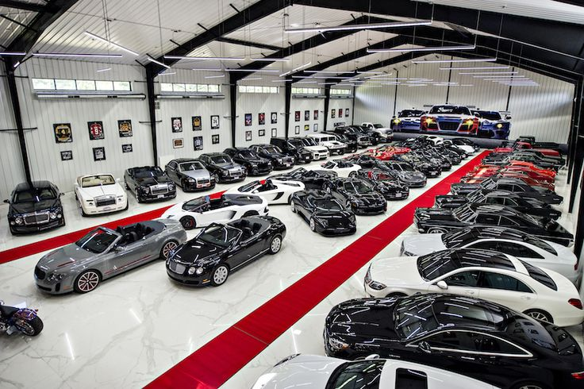

Submitted by

SUGAMAN.A

XII – G

Reg.No:



**CERTIFICATE**

**COMPUTER SCIENCE**

Certified to be the bonafide project work done by **SUGAMAN.A**

of Class **XII** Section **G** in Pushpalata Vidya Mandir, Tirunelveli-11 during the academic year 2022-2023.

Signature of Principal Signature of Teacher

School Seal

Submitted for Senior School Certificate Practical Examination held in **COMPUTER SCIENCE** at ***Pushpalata Vidya Mandir Senior Secondary School, Tirunelveli.***

Date :

Internal Examiner External Examiner

**ACKNOWLEDGEMENT**

I wish to express my deep gratitude and sincere thanks to Senior Principal **Mrs. PUSHPAVENI AYYAPPAN** for her encouragement and facilities that she provided for this project work. I sincerely appreciate this magnanimity by taking me into her fold for which I shall remain indebted to her.

I extend my hearty thanks to my Computer Science teacher Ms. Hannah who guided me to the successful completion of this project.

I take this opportunity to express my deep sense of gratitude for their invaluable guidance, constant encouragement, constructive comments, sympathetic attitude and immense motivation, which has sustained my efforts at all stages of this project work.

**INDEX**

|  |  |  |
| --- | --- | --- |
| **S.NO** | **TITLE** | **PAGE.NO** |
| 1 | Description | 05 |
| 2 | Source Code | 07 |
| 3 | Output | 140 |

**DESCRIPTION**

**PROBLEM DEFINITION:**

In the existing scenario, if the customer wishes to purchase a car, they have to visit the showroom. It is very difficult because its time consuming. So our project aims at creating a user friendly application for booking a car.

**OBJECTIVE:**

Vehicle management system is software designed to meet the needs of the people. It helps the users to get clear idea about both cars and supercars. We provide all the specifications of the cars which helps the user to identify and buy his/her dream car.

**METHODOLOGY:**

The project is designed for both admin and users.

**1. Admin:**

The admin has to login with their unique reference id and password. After successful login, the admin can access the details about the users logged in, booked users, and the details of the customers who’ve cancelled their booking.

The admin can view the details like username, user’s mail, phone number, address, the brand and model the user have chosen, total amount and amount paid.

**2. User**:

The customers must provide the software with the details enquired by the module for signing up or to log into an existing account. A unique id is assigned for all the users.

* Cars module: This module lists out the brand of the cars with its specifications like cc, BHP, Torque, top speed, transmission, mileage, tank and seat capacity, price. If the user likes the brand he/she can confirm the booking by paying 30% of the total amount.
* User edit: This module is defined to let the customers to edit their personal details like username, password, mail id and address.

The customer can also cancel their booking only before 7 days of the expected arrival date.

**Tools/Platform Used:**

Python Programming language is used as the front end and MySQL is used as the back end for implementing the project.

**SOURCE CODE:**

import csv,random,sys,datetime

from datetime import date

f1=open('login.csv','a+',newline="")

f2=open('admin.csv','a+',newline="")

f3=open('car_booking.csv','a+',newline="")

f4=open('cancelled_booking.csv','a+',newline="")

def cars():

def incars():

print('\t\t\tBRAND')

print('[1] Audi [5] Honda [9] Mercedes Benz [13] Rollsroyce')

print('[2] BMW [6] Hyundai [10] Nissan [14] Toyata')

print('[3] Bugatti [7] Lamborgini [11] Pagani [15] Volkswagen')

print('[4] Devel sixteen [8] Koenigsegg [12] Porsche [16] Aston martin')

global bb

global c

global p

a = int(input('Select the required brand:'))

if a == 1:

bb='Audi'

print('[1]AUDI Q5')

print('[2]AUDI Q7')

print('[3]AUDI Q8')

print('[4]AUDI A4')

print('[5]AUDI A6')

print('[6]AUDI Q2')

print('[7]AUDI RS7')

print('[8]AUDI A8L')

print('[9]AUDI e-tron')

print('[10]Audi e-tron GT')

print('[11]AUDI RS etron GT')

print('[12]AUDI RS Q8')

print('[13]AUDI RS5')

print('[14]AUDI RS5 SPORTSBACK')

print('[15]AUDI A3')

print('[16]AUDI Q3')

model_C = int(input('Select the Model:'))

print('\nSPECIFICATIONS')

if model_C == 1:

c='AUDI Q5'

print('\tCC-1984')

print('\tBHP-245.59@5000rpm')

print('\tTorque-320Nm@1600-4500rpm')

print('\tTRANSMISSION- Automatic')

print('\tTOP SPEED -220kmph')

print('\tMileage-13.45')

print('\tTank capacity-85L')

print('\tSeats-5')

print('\tPrice-59-65.5 Lakhs')

p=6200000

if model_C == 2:

c='AUDI Q7'

print('\tCC- 2995')

print('\tBHP-335.25bhp@5000-6400rpm')

print('\tTorque-370Nm@1600-4500rpm')

print('\tTRANSMISSION- Automatic')

print('\tTOP SPEED -240Kmph')

print('\tMileage-11.2')

print('\tTank capacity-75L')

print('\tSeats-4')

print('\tPrice-82.48 lakhs -89.89 lakhs')

p=8500000

if model_C == 3:

c='AUDI Q8'

print('CC-2995')

print('BHP-335.25bhp@5000-6400rpm')

print('Torque-320nm@1450–4200')

print('TRANSMISSION-Automatic')

print('TOP SPEED -220kmph')

print('Mileage-9.8')

print('Tank capacity-80L')

print('Seats-5')

print('Price-55Lakhs')

p=5500000

if model_C == 4:

c='AUDI A4'

print('CC-1998')

print('BHP-187.74bhp@4200-6000')

print('Torque-320nm@1450–4200')

print('TRANSMISSION-Automatic')

print('TOP SPEED -250kmph')

print('Mileage-17.42Kmpl')

print('Tank capacity-54Litres')

print('Seats-5')

print('Price-49.97 Lakh')

p=4997000

if model_C == 5:

c='AUDI A6'

print('CC-1984')

print('BHP-241.3bhp@5000-6500rpm')

print('Torque-370Nm@1600-4500rpm')

print('TRANSMISSION-Automatic')

print('TOP SPEED -260kmph')

print('Mileage-14.11 Kmpl')

print('Tank capacity-73Litres')

print('Seats-5')

print('Price-65.99Lakh')

p=6599000

if model_C == 6:

c='AUDI Q2'

print('CC-1984')

print('BHP-187.74bhp@4200-6000rpm')

print('Torque-320nm@1500–4180rpm')

print('TRANSMISSION-Automatic')

print('TOP SPEED -260kmph')

print('Mileage-6.5Kmpl')

print('Tank capacity-55Litres')

print('Seats-5')

print('Price-34.99-48.89L')

p=4889000

if model_C == 7:

c='AUDI RS7'

print('CC-3996')

print('BHP-591bhp@6000-6250rpm')

print('Torque-800nm@2050-4500rpm')

print('TRANSMISSION-Automatic')

print('TOP SPEED -220kmph')

print('Mileage-8.9Kmpl')

print('Tank capacity-73Litres')

print('Seats-4')

print('Price-2.24 Cr')

p=22400000

if model_C == 8:

c='AUDI A8L'

print('CC-2995')

print('BHP-335.25bhp@5000-6400rpm')

print('Torque-500nm@1370-4500rpm')

print('TRANSMISSION-Automatic')

print('TOP SPEED -250kmph')

print('Mileage-11kmpl')

print('Tank capacity-73Litres')

print('Seats-4')

print('Price-1.57Cr')

p=157000

if model_C == 9:

c='AUDI e-tron'

print('CC-2995')

print('BHP-300')

print('Torque-630N.m')

print('TRANSMISSION-Automatic')

print('TOP SPEED -250kmph')

print('Range-264-379km')

print('Seats-5')

print('Price-1.19Cr')

p=11900000

if model_C == 10:

c='Audi e-tron GT'

print('CC-2995')

print('BHP-475 kW')

print('Torque-830Nm')

print('TRANSMISSION-Automatic')

print('TOP SPEED -220kmph')

print('Range-388-500km')

print('Seats-5')

print('Price-1.66cr')

p=16600000

if model_C == 11:

c='AUDI RS etron GT'

print('CC-2995')

print('BHP-636.98bhp')

print('Torque-830Nm')

print('TRANSMISSION-Automatic')

print('TOP SPEED -190kmph')

print('Range-401-481km')

print('charging time-5:15hrs(5-80#)')

print('Seats-4')

print('Price-1.89 Cr')

p=18900000

if model_C == 12:

c='AUDI RS Q8'

print('CC-3998')

print('BHP-591.39bhp@6000rpm')

print('Torque-800nm@2200-4500rpm')

print('TRANSMISSION-Automatic')

print('TOP SPEED -200kmph')

print('Mileage-8.26kmpl')

print('Tank capacity-85Litres')

print('Seats-5')

print('Price-2.17cr')

p=21700000

if model_C == 13:

c='AUDI RS5'

print('CC-2984')

print('BHP-443.87bhp@5700-6700rpm')

print('Torque-600nm@1900-5000rpm')

print('TRANSMISSION-Automatic')

print('TOP SPEED -250kmph')

print('Mileage-8.8kmpl')

print('Tank capacity-58Litres')

print('Seats-4')

print('Price-1.09cr')

p=10900000

if model_C == 14:

c='AUDI RS5 SPORTSBACK'

print('CC-2894')

print('BHP-443.87@5700-6700rpm')

print('Torque-600nm@1900-5000rpm')

print('TRANSMISSION-Automatic')

print('TOP SPEED -230kmph')

print('Mileage-8.8kmpl')

print('Tank capacity-58Litres')

print('Seats-4')

print('Price-1.09cr')

p=10900000

if model_C == 15:

c='AUDI A3'

print('CC-1998')

print('BHP-148 bhp @ 5000 rpm')

print('Torque-250 Nm @ 1500 rpm')

print('TRANSMISSION-Automatic')

print('TOP SPEED -220kmph')

print('Mileage-8.8kmpl')

print('Tank capacity-58Litres')

print('Seats-5')

print('Price-35Lakhs')

p=3500000

if model_C == 16:

c='AUDI Q3'

print('CC-1984')

print('BHP-148hp@3500-4000rpm')

print('Torque-340Nm@1750-2750rpm')

print('TRANSMISSION-Automatic')

print('TOP SPEED -190kmph')

print('Mileage-12kmpl')

print('Tank capacity-64Litres')

print('Seats-5')

print('Price-45Lakhs')

p=4500000

elif model_C < 1 or model_C > 16:

print('Select the appropriate model ')

cars()

if a == 2:

bb='BMW'

print('[1]BMW X3')

print('[2]BMW X6')

print('[3]BMW 3 SERIES')

print('[4]BMW 5 SERIES')

print('[5]BMW X7')

print('[6]BMW 2 SERIES')

print('[7]BMW M4 COMPETITION')

print('[8]BMW M5')

print('[9]BMW X4')

print('[10]BMW 7 SERIES')

print('[11]BMW M2')

print('[12]BMW X5 M')

print('[13]BMW X1')

print('[14]BMW iX')

print('[15]BMW i4')

print('[16]BMW 6 SERIES')

print('[17]BMW Z4')

print('[18]BMW 8 SERIES')

print('[19]BMW X3 M')

print('[20]BMW iX1')

print('[21]BMW X1')

print('[22]BMW i7')

print('[23]BMW i8')

print('[24]BMW M8')

print('[25]BMW M5')

model_C = int(input('Select the Model:'))

print('\nSPECIFICATIONS')

if model_C == 1:

c='BMW X3'

print('CC-1998')

print('BHP-248.08bhp@5200rpm')

print('Torque-350nm@1450-4800rpm')

print('TRANSMISSION-Automatic')

print('TOP SPEED -250kmph')

print('Mileage-13.17kmpl')

print('Tank capacity-63Litres')

print('Seats-5')

print('Price-61.90-67.90Lakhs')

p=6790000

if model_C == 2:

c='BMW X6'

print('CC-1998')

print('BHP-335.25bhp@5500-6500rpm')

print('Torque-450Nm@1500-5200rpm')

print('TRANSMISSION-Automatic')

print('TOP SPEED -250kmph')

print('Mileage-10.35kmpl')

print('Tank capacity-83Litres')

print('Seats-5')

print('Price-1.04 Cr')

p=10400000

if model_C == 3:

c='BMW 3 SERIES'

print('CC-2998')

print('BHP-382.19bhp@5800rpm')

print('Torque-500Nm@1850-5000rpm')

print('TRANSMISSION-Automatic')

print('TOP SPEED -250kmph')

print('Mileage-10.3kmpl')

print('Tank capacity-59Litres')

print('Seats-5')

print('Price-46.90 - 68.90 Lakh')

p=6890000

if model_C == 4:

c='BMW 5 SERIES'

print('CC-2998')

print('BHP-261.49bhp@4000rpm')

print('Torque-620nm@2000–2500rpm')

print('TRANSMISSION-Automatic')

print('TOP SPEED -250kmph')

print('Mileage-17.37kmpl')

print('Tank capacity-63Litres')

print('Seats-5')

print('Price-46.90-69.90Lakhs')

p=6990000

if model_C == 5:

c='BMW X7'

print('CC-2993')

print('BHP-394.26bhp@4400rpm')

print('Torque-760nm@2000-3000rpm')

print('TRANSMISSION-Automatic')

print('TOP SPEED -250kmph')

print('Mileage-12kmpl')

print('Tank capacity-80Litres')

print('Seats-5')

print('Price-1.18 - 1.78 Cr')

p=17800000

if model_C == 6:

c='BMW 2 SERIES'

print('CC-2998')

print('BHP-187.74bhp@4000rpm')

print('Torque-400nm@1750-2500rpm')

print('TRANSMISSION-Automatic')

print('TOP SPEED -250kmph')

print('Mileage-13.38kmpl')

print('Tank capacity-50Litres')

print('Seats-7')

print('Price-41.50 - 44.50 Lakh')

p=4450000

if model_C == 7:

c='BMW M4 COMPETITION'

print('CC-1998')

print('BHP-502.88bhp@6250rpm')

print('Torque-650Nm@2750-5500rpm')

print('TRANSMISSION-Automatic')

print('TOP SPEED -230kmph')

print('Mileage-18.64Kmpl')

print('Tank capacity-50litres')

print('Seats-5')

print('Price-s.1.44 Cr')

p=14400000

if model_C == 8:

c='BMW M5'

print('CC-2993')

print('BHP-616.87bhp@6000rpm')

print('Torque-750nm@1800-5860rpm')

print('TRANSMISSION-Automatic')

print('TOP SPEED -280kmph')

print('Mileage-9.12kmpl')

print('Tank capacity-40Litres')

print('Seats-5')

print('Price-1.44Crore')

p=14400000

if model_C == 9:

c='BMW X4'

print('CC-4395')

print('BHP-261.49bhp@4000rpm')

print('Torque-620Nm@2000-2500rpm')

print('TRANSMISSION-Automatic')

print('TOP SPEED -320kmph')

print('Mileage-14kmpl')

print('Tank capacity-65Litres')

print('Seats-5')

print('Price-71.90 - 73.90 Lakh')

p=7390000

if model_C == 10:

c='BMW 7 SERIES'

print('CC-2998')

print('BHP-281.6bhp@5000-6000rpm')

print('Torque-450Nm@1380-5000rpm')

print('TRANSMISSION-Automatic')

print('TOP SPEED -250kmph')

print('Mileage-39.36Kmpl')

print('Tank capacity-46Litres')

print('Seats-4')

print('Price-1.42 - 1.76 Cr')

p=17600000

if model_C == 11:

c='BMW M2'

print('CC-2998')

print('BHP-410bhp@6250rpm')

print('Torque-550Nm@2350-5230rpm')

print('TRANSMISSION-Automatic')

print('TOP SPEED -250kmph')

print('Mileage-10.53kmpl')

print('Tank capacity-64Litres')

print('Seats-5')

print('Price-85.00 Lakh')

p=8500000

if model_C == 12:

c='BMW X5 M'

print('CC-2979')

print('BHP-616.87bhp@6000rpm')

print('Torque-750nm@1800-5600rpm')

print('TRANSMISSION-Automatic')

print('TOP SPEED -260kmph')

print('Mileage-10.63kmpl')

print('Tank capacity-83Litres')

print('Seats-4')

print('Price-2.08 Cr')

p=2080000

if model_C == 13:

c='BMW X1'

print('CC-1995')

print('BHP-187.74bhp@5000-6000rpm')

print('Torque-400nm@1750-2500rpm')

print('TRANSMISSION-Automatic')

print('TOP SPEED -260kmph')

print('Mileage-18.29kmpl')

print('Tank capacity-51Litres')

print('Seats-5')

print('Price-41.50 - 44.50 Lakh')

p=4450000

if model_C == 14:

c='BMW iX'

print('CC-1998')

print('BHP-321.84Bhp')

print('Torque-630Nm')

print('TRANSMISSION-Automatic')

print('TOP SPEED -250kmph')

print('Mileage-19.62kmpl')

print('Charging time-7.25hours')

print('Seats-5')

print('Price-1.16 Cr')

p=11600000

if model_C == 15:

c='BMW i4'

print('CC-2998')

print('BHP-335.25bhp')

print('Torque-430Nm')

print('TRANSMISSION-Automatic')

print('TOP SPEED -190kmph')

print('range- 493-590Km')

print('battery capacity- 83.9Kw-')

print('Seats-5')

print('Price-69.90 Lakh')

p=6990000

if model_C == 16:

c='BMW 6 SERIES'

print('CC-2993')

print('BHP-261.4bhp@4000rpm')

print('Torque-620Nm@2000-2500rpm')

print('TRANSMISSION-Automatic')

print('TOP SPEED -230kmph')

print('Mileage-17.09kmpl')

print('Tank capacity-66Litres')

print('Seats-4')

print('Price-69.90 - 79.90 Lakhs')

p=7990000

if model_C == 17:

c='BMW Z4'

print('CC-2998')

print('BHP-335bhp@5000-6500rpm')

print('Torque-500Nm@1600-4500rpm')

print('TRANSMISSION-Automatic')

print('TOP SPEED -230kmph')

print('Mileage-14.37kmpl')

print('Tank capacity-52Litres')

print('Seats-4')

print('Price-71.90 - 84.90 Lakh')

p=8490000

if model_C == 18:

c='BMW 8 SERIES'

print('CC-2998')

print('BHP-600bhp@6000rpm')

print('Torque-750nm@1800-5600rpm')

print('TRANSMISSION-Automatic')

print('TOP SPEED -260kmph')

print('Mileage-5.37kmpl')

print('Tank capacity-68Litres')

print('Seats-2')

print('Price-1.62 - 2.23 Cr')

p=22300000

if model_C == 19:

c='BMW X3 M'

print('CC-2993')

print('BHP-473.38bhp@6250rpm')

print('Torque-600nm@2600-5600rpm')

print('TRANSMISSION-Automatic')

print('TOP SPEED -260kmph')

print('Mileage-9.3kmpl')

print('Tank capacity-65Litres')

print('Seats-4')

print('Price-99.90 Lakh')

p=9990000

if model_C == 20:

c='BMW iX1'

print('CC-2993')

print('BHP-187.74bhp@5000-6000rpm')

print('Torque-400nm@1750-2500rpm')

print('TRANSMISSION-Automatic')

print('TOP SPEED -220kmph')

print('Mileage-9.14kmpl')

print('Tank capacity-74Litres')

print('Seats-4')

print('Price-60.00 Lakh')

p=6000000

if model_C == 21:

c='BMW X1'

print('CC-1995')

print('BHP-187.74bhp@5000-6000rpm')

print('Torque-400nm@1750-2500rpm')

print('TRANSMISSION-Automatic')

print('TOP SPEED -220kmph')

print('Mileage-19.62kmpl')

print('Tank capacity-51Litres')

print('Seats-5')

print('Price-41.50 - 44.50 Lakh')

p=4450000

if model_C == 22:

c='BMW i7'

print('CC-1998')

print('BHP-257.47@rpm')

print('Torque-289@rpm')

print('TRANSMISSION-Automatic')

print('TOP SPEED -260kmph')

print('Mileage-19.62kmpl')

print('Tank capacity-85Litres')

print('Seats-5')

print('Price-2.50 Cr')

p=25000000

if model_C == 23:

c='BMW i8'

print('CC-1499')

print('BHP-228bhp@5800rpm')

print('Torque-320Nm@3700rpm')

print('TRANSMISSION-Automatic')

print('TOP SPEED -220kmph')

print('Mileage-47.45kmpl')

print('Tank capacity-42Litres')

print('Seats-4')

print('Price-2.50Crore')

p=25000000

if model_C == 24:

c='BMW M8'

print('CC-4935')

print('BHP-600bhp@6000rpm')

print('Torque-750nm@1800-5600rpm')

print('TRANSMISSION-Automatic')

print('TOP SPEED -220kmph')

print('Mileage-5.59kmpl')

print('Tank capacity-68Litres')

print('Seats-4')

print('Price-2.23Crore')

p=22300000

if model_C == 25:

c='BMW M5'

print('CC-4395cc')

print('BHP-616.87bhp@6000rpm')

print('Torque-750nm@1800-5860rpm')

print('TRANSMISSION-Automatic')

print('TOP SPEED -260kmph')

print('Mileage-9.12kmpl')

print('Tank capacity-74Litres')

print('Seats-5')

print('Price-1.74Crore')

p=17400000

elif model_C < 1 or model_C > 25:

print('Select the appropriate model ')

cars()

if a == 3:

bb='BUGATTI'

print('[1]BUGATTI VEYRON')

print('[2]BUGATTI CHIRON')

print('[3]BUGATTI DIVO')

print('[4]BUGATTI CENTODIECI')

print('[5]BUGATTI LA VOITURE NOIRE')

print('[6]BUGATTI VISION GRANTURISMO')

print('[7]BUGATTI BOLIDE')

print('[8]BUGATTI VEYRON 16.4 SUPER SPORT')

print('[9]BUGATTI CHIRON SUPER SPORT')

print('[10]BUGATTI CHIRON PUR SPORT')

print('[11]BUGATTI CHIRON SPORT')

print('[12]BUGATTI CHIRON Les Légendes Du Ciel')

print('[13]BUGATTI CHIRON EDITION NOIRE')

print('[14]BUGATTI CHIRON SUPERSPORT 300+')

print('[15]BUGATTI CHIRON 110 ANS')

model_C = int(input('Select the Model:'))

print('\nSPECIFICATIONS')

if model_C == 1:

c='BUGATTI VEYRON'

print('CC-7993')

print('BHP-1001bhp@6000rpm')

print('Torque-1250Nm@2200-5500rpm')

print('TRANSMISSION-Automatic')

print('TOP SPEED -300kmph')

print('Mileage-6kmpl')

print('Tank capacity-100Litres')

print('Seats-2')

print('Price-12Crore')

p=120000000

if model_C == 2:

c='BUGATTI CHIRON'

print('CC-7993')

print('BHP-1600Nm@2000-6000rpm')

print('Torque-1479bhp@6700rpm')

print('TRANSMISSION-Automatic')

print('TOP SPEED -300kmph')

print('Mileage-6kmpl')

print('Tank capacity-90Litres')

print('Seats-2')

print('Price-21Crore')

p=210000000

if model_C == 3:

c='BUGATTI DIVO'

print('CC-7993')

print('BHP-1479bhp@6700rpm')

print('Torque-1600Nm@2000-6000rpm')

print('TRANSMISSION-Automatic')

print('TOP SPEED -304kmph')

print('Mileage-7kmpl')

print('Tank capacity-90Litres')

print('Seats-2')

print('Price-41Crore')

p=410000000

if model_C == 4:

c='BUGATTI CENTODIECI'

print('CC-8000')

print('BHP-1600 hp @ 7000 rpm')

print('Torque-1180 ft-lb')

print('TRANSMISSION-Automatic')

print('TOP SPEED -236mph')

print('Mileage-7kmpl')

print('Tank capacity-100Litres')

print('Seats-2')

print('Price-66Crores')

p=660000000

if model_C == 5:

c='BUGATTI LA VOITURE NOIRE'

print('CC-7993')

print('BHP-1500 PS @ 6700rpm')

print('Torque-1600 Nm @ 2000 - 6000rpm')

print('TRANSMISSION-Automatic')

print('TOP SPEED -260kmph')

print('Mileage-7kmpl')

print('Tank capacity-90Litres')

print('Seats-2')

print('Price-98Crore')

p=980000000

if model_C == 6:

c='BUGATTI VISION GRANTURISMO'

print('CC-7993')

print('BHP-1,479 BHP @ around 6,700 rpm')

print('Torque- 1,600 Nm @ 2,000 - 6,000 rpm')

print('TRANSMISSION-Automatic')

print('TOP SPEED -280kmph')

print('Mileage-7.6kmpl')

print('Tank capacity-100Litres')

print('Seats-2')

print('Price-21Crore')

p=210000000

if model_C == 7:

c='BUGATTI BOLIDE'

print('CC-1451')

print('BHP-1,177 kW (1,578 hp; 1,600 PS)')

print('Torque-1,600 N⋅m (1,180 lbf⋅ft) at 2,250 rpm')

print('TRANSMISSION-Automatic')

print('TOP SPEED -250kmph')

print('Mileage-9kmpl')

print('Tank capacity-75Litres')

print('Seats-2')

print('Price-19.21Crore')

p=192100000

if model_C == 8:

c='BUGATTI VEYRON 16.4 SUPER SPORT'

print('CC-7993')

print('BHP-987 bhp @ 6000 rpm ')

print('Torque-1250 Nm @ 2200 rpm')

print('TRANSMISSION-Automatic')

print('TOP SPEED -280kmph')

print('Mileage-9.3kmpl')

print('Tank capacity-90Litres')

print('Seats-2')

print('Price- ₹ 11.39 Crore')

p=113900000

if model_C == 9:

c='BUGATTI CHIRON SUPER SPORT'

print('CC-7993')

print('BHP-1479bhp@6700rpm')

print('Torque-1600Nm@2000-6000rpm')

print('TRANSMISSION-Automatic')

print('TOP SPEED -280kmph')

print('Mileage-7kmpl')

print('Tank capacity-90Litres')

print('Seats-2')

print('Price-19.21Crores')

p=192100000

if model_C == 10:

c='BUGATTI CHIRON PUR SPORT'

print('CC-7993')

print('BHP-1479 BHp ps ')

print('Torque-1600 N·m1180 lb·ft')

print('TRANSMISSION-Automatic')

print('TOP SPEED -250kmph')

print('Mileage-7kmpl')

print('Tank capacity-75Litres')

print('Seats-2')

print('Price-21Crore')

p=210000000

if model_C == 11:

c='BUGATTI CHIRON SPORT'

print('CC-7993')

print('BHP-1479 bhp @ 6700 rpm')

print('Torque-1600Nm@2000-6000rpm')

print('TRANSMISSION-Automatic')

print('TOP SPEED -280kmph')

print('Mileage-7.9kmpl')

print('Tank capacity-75Litres')

print('Seats-2')

print('Price-21Crore')

p=210000000

if model_C == 12:

c='BUGATTI CHIRON Les Légendes Du Ciel'

print('CC-7993')

print('BHP- 1,500 PS')

print('Torque-1600Nm')

print('TRANSMISSION-Automatic')

print('TOP SPEED -300kmph')

print('Mileage-5kmpl')

print('Tank capacity-100Litres')

print('Seats-2')

print('Price-21Crore')

p=210000000

if model_C == 13:

c='BUGATTI CHIRON EDITION NOIRE'

print('CC-7993')

print('BHP-@rpm 1,103 kW (1,479 hp; 1,500 PS) ')

print('Torque-1,600 N⋅m (1,180 lb⋅ft)')

print('TRANSMISSION-Automatic')

print('TOP SPEED -300kmph')

print('Mileage-5Litres')

print('Tank capacity-100Litres')

print('Seats-2')

print('Price-21Crore')

p=210000000

if model_C == 14:

c='BUGATTI CHIRON SUPERSPORT 300+'

print('CC-7993')

print('BHP-1,577 hp @ 7,000 rpm (1,176 kW)')

print('Torque-1,180 lb·ft @ 2,000 – 6,000 rpm (1,600 N·m)')

print('TRANSMISSION-Automatic')

print('TOP SPEED -260kmph')

print('Mileage-5kmpl')

print('Tank capacity-100Litres')

print('Seats-2')

print('Price-92Crore')

p=920000000

if model_C == 15:

c='BUGATTI CHIRON 110 ANS'

print('CC-7993')

print('BHP-1,479 hp @ 6,900 rpm (1,103 kW)')

print('Torque-1,180 lb·ft @ 2,000 – 6,000 rpm (1,600 N·m)')

print('TRANSMISSION-Automatic')

print('TOP SPEED -320kmph')

print('Mileage-5kmpl')

print('Tank capacity-100Litres')

print('Seats-2')

print('Price-106Crore')

p=106000000

elif model_C < 1 or model_C > 15:

print('Select the appropriate model ')

cars()

if a == 4:

bb='DEVEL SIXTEEN'

print('[1]DEVEL SIXTEEN V16')

model_C = int(input('Select the Model:'))

print('\nSPECIFICATIONS')

if model_C == 1:

c='DEVEL SIXTEEN V16'

print('CC-12300')

print('BHP-5007 HP')

print('Torque-5090 Nm')

print('TRANSMISSION-Automatic')

print('TOP SPEED -500kmph')

print('Mileage-5kmpl')

print('Tank capacity-100Litres')

print('Seats-2')

print('Price-44.96Crore')

p=449600000

elif model_C < 1 or model_C > 1:

print('Select the appropriate model ')

cars()

if a == 5:

bb='HONDA'

print('[1]HONDA CITY')

print('[2]HONDA AMAZE')

print('[3]HONDA JAZZ')

print('[4]HONDA CIVIC')

print('[5]HONDA CIVIC TYPE R')

print('[6]HONDA CR V')

print('[7]HONDA BR V')

print('[8]HONDA WR V')

print('[9]HONDA HR V')

print('[10]HONDA CITY HYBRID EHEV')

model_C = int(input('Select the Model:'))

print('\nSPECIFICATIONS')

if model_C ==1:

c='HONDA CITY'

print('CC-1498')

print('BHP-97.89bhp@3600rpm')

print('Torque-200Nm@1750rpm')

print('TRANSMISSION-Automatic')

print('TOP SPEED -195kmph')

print('Mileage-15.32kmpl')

print('Tank capacity-40L')

print('Seats-5')

print('Price-11.57-15.52Lakhs')

p=1552000

if model_C ==2:

c='HONDA AMAZE'

print('CC-1498')

print('BHP-79.12bhp@3600rpm')

print('Torque-160Nm@1750rpm')

print('TRANSMISSION-Automatic/Manual')

print('TOP SPEED -160kmph')

print('Mileage-24.7kmpl')

print('Tank capacity-35Litres')

print('Seats-5')

print('Price-6.63 - 11.50 Lakh')

p=1150000

if model_C ==3:

c='HONDA JAZZ'

print('CC-1199')

print('BHP-88.50bhp@6000rpm')

print('Torque-110Nm@4800rpm')

print('TRANSMISSION-Automatic')

print('TOP SPEED -172kmph')

print('Mileage-17.1kmpl')

print('Tank capacity-40')

print('Seats-5')

print('Price-Rs.8.01 - 10.32 Lakh')

p=1032000

if model_C ==4:

c='HONDA CIVIC'

print('CC-1799')

print('BHP-139@6500rpm')

print('Torque-174@4300rpm')

print('TRANSMISSION-Manual')

print('TOP SPEED -270kmph')

print('Mileage-16.5kmpl')

print('Tank capacity-47')

print('Seats-5')

print('Price-15.00 Lakh - 22.35 Lakh')

p=2235000

if model_C ==5:

c='HONDA CIVIC TYPE R'

print('CC-1996')

print('BHP-217@8000rpm')

print('Torque-295 lb-ft @ 2500-4500 rpm')

print('TRANSMISSION-Manual')

print('TOP SPEED -261kmph')

print('Mileage-26.8kmpl')

print('Tank capacity-47Litres')

print('Seats-5')

print('Price-58Lakh')

p=5800000

if model_C ==6:

c='HONDA CR V'

print('CC-1997')

print('BHP-151.89bhp@6500rpm')

print('Torque-189NM@4300rpm')

print('TRANSMISSION- Automatic')

print('TOP SPEED - 195kmph')

print('Mileage-14.4 kmpl')

print('Tank capacity-57Litres')

print('Seats-5')

print('Price-21.10 Lakh - 32.77 Lakh')

p=3277000

if model_C ==7:

c='HONDA BR V'

print('CC-1497')

print('BHP-117.3bhp@6600rpm')

print('Torque-145Nm@4600rpm')

print('TRANSMISSION-Manual')

print('TOP SPEED -')

print('Mileage-15.4kmpl')

print('Tank capacity-42Litres')

print('Seats-7')

print('Price-9.53 Lakh - 13.83 Lakh')

p=1383000

if model_C ==8:

c='HONDA WR V'

print('CC-1498')

print('BHP-88.7bhp@6000rpm')

print('Torque-110Nm@4800rpm')

print('TRANSMISSION- Manual')

print('TOP SPEED -176kmph')

print('Mileage-17.5kmpl')

print('Tank capacity-40Litres')

print('Seats-5')

print('Price-8.08 Lakh - 10.48 Lakh')

p=1048000

if model_C ==9:

c='HONDA HR V'

print('CC-1198')

print('BHP-@rpm')

print('Torque-@rpm')

print('TRANSMISSION-Manual')

print('TOP SPEED -')

print('Mileage-')

print('Tank capacity-')

print('Seats-5')

print('Price-14.00 Lakh')

p=1400000

if model_C ==10:

c='HONDA CITY HYBRID EHEV'

print('CC-1498')

print('BHP-96.55bhp@5600-6400rpm')

print('Torque-127nm@4500-5000')

print('TRANSMISSION-Automatic')

print('TOP SPEED -170kmph')

print('Mileage-26.5kmpl')

print('Tank capacity-40Litres')

print('Seats-5')

print('Price-19.89 Lakh')

p=1989000

elif model_C < 1 or model_C >10:

print('Select the appropriate model ')

cars()

if a == 6:

bb='HYUNDAI'

print('[1] HYUNDAI ELENTRA')

print('[2] HYUNDAI STARGAZER')

print('[3] HYUNDAI CASPER')

print('[4] HYUNDAI CRETA')

print('[5] HYUNDAI KONA')

print('[6] HYUNDAI i10 grandnios')

print('[7] HYUNDAI i20')

print('[8] HYUNDAI AURA')

print('[9] HYUNDAI VERNA')

print('[10] HYUNDAI VENUE')

print('[11] HYUNDAI TUCRON')

print('[12] HYUNDAI SANTRO')

print('[13] HYUNDAI ALCAZAR')

print('[14] HYUNDAI i20 N LINE')

model_C = int(input('Select the Model:'))

print('\nSPECIFICATIONS')

if model_C ==1:

c='HYUNDAI ELENTRA'

print('CC-1582')

print('BHP-126.2bhp@4000rpm')

print('Torque-259.88Nm@1900-2750rpm')

print('TRANSMISSION-Manual')

print('TOP SPEED -150kmph')

print('Mileage-14.59kmpl')

print('Tank capacity-50Litres')

print('Seats-5')

print('Price-15.00- 21.13 Lakh')

p=2113000

if model_C ==2:

c='HYUNDAI STARGAZER'

print('CC-1499')

print('BHP-116.2bhp@4000rpm')

print('Torque-259.88Nm@1900-2750rpm')

print('TRANSMISSION-Manual')

print('TOP SPEED -180kmph')

print('Mileage-11kmpl')

print('Tank capacity-50L')

print('Seats-4')

print('Price-10.00 Lakh')

p=1000000

if model_C ==3:

c='HYUNDAI CASPER'

print('CC-999')

print('BHP-116.2bhp@4000rpm')

print('Torque-259.88Nm@1900-2750rpm')

print('TRANSMISSION-Manual')

print('TOP SPEED -160kmph')

print('Mileage-12.4kmpl')

print('Tank capacity-60L')

print('Seats-5')

print('Price-6.00Lakhs')

p=600000

if model_C ==4:

c='HYUNDAI CRETA'

print('CC-1493')

print('BHP-113.45bhp@4000rpm')

print('Torque-250nm@1500-2750rpm')

print('TRANSMISSION-Automatic')

print('TOP SPEED -150kmpl')

print('Mileage-18kmpl')

print('Tank capacity-50Litres')

print('Seats-5')

print('Price-10.44 - 18.18 Lakh')

p=1818000

if model_C ==5:#electric

c='HYUNDAI KONA'

print('CC-1493')

print('BHP-134.10bhp')

print('Torque-395Nm')

print('TRANSMISSION-Automatic')

print('TOP SPEED -160kmpl')

print('Mileage-14.3kmpl')

print('charging time- Approx 6 h 10 min')

print('Seats-5')

print('Price-23.84 - 24.03 Lakh')

p=2403000

if model_C ==6:

c='HYUNDAI i10 grandnios'

print('CC-1197')

print('BHP-81.86bhp@6000rpm')

print('Torque-113.8nm@4000rpm')

print('TRANSMISSION-Automatic')

print('TOP SPEED -150kmph')

print('Mileage-20.7kmpl')

print('Tank capacity-37Litres')

print('Seats-5')

print('Price-5.39 - 8.02 Lakh')

p=802000

if model_C ==7:

c='HYUNDAI i20'

print('CC-1493')

print('BHP-118.36bhp@6000rpm')

print('Torque-171.62nm@1500-4000rpm')

print('TRANSMISSION-Automatic')

print('TOP SPEED -175kmph')

print('Mileage-20.28kmpl')

print('Tank capacity-37Litres')

print('Seats-5')

print('Price-7.03 - 11.54 Lakh')

p=1154000

if model_C ==8:

c='HYUNDAI AURA'

print('CC-1197')

print('BHP-98.63bhp@6000rpm')

print('Torque-172nm@1500-4000rpm')

print('TRANSMISSION-Manual')

print('TOP SPEED -150kmph')

print('Mileage-20.5kmpl')

print('Tank capacity-37Litres')

print('Seats-5')

print('Price-6.09 - 8.87 Lakh')

p=887000

if model_C ==9:

c='HYUNDAI VERNA'

print('CC-1497')

print('BHP-113.45bhp@4000rpm')

print('Torque-250Nm@1500-2750rpm')

print('TRANSMISSION-Automatic')

print('TOP SPEED -140kmph')

print('Mileage-21.3kmpl')

print('Tank capacity-45Litres')

print('Seats-5')

print('Price-9.41 - 15.45 Lakh')

p=1545000

if model_C ==10:

c='HYUNDAI VENUE'

print('CC-998')

print('BHP-118.41bhp@6000rpm')

print('Torque-172Nm@1500-4000rpm')

print('TRANSMISSION-Automatic')

print('TOP SPEED -160kmph')

print('Mileage-16.0kmpl(city)')

print('Tank capacity-45Litres')

print('Seats-5')

print('Price-7.53 - 12.72 Lakh')

p=1272000

if model_C ==11:

c='HYUNDAI TUCRON'

print('CC-1997')

print('BHP-183.72bhp@4000rpm')

print('Torque-416nm@2000-2750rpm')

print('TRANSMISSION-Automatic')

print('TOP SPEED -150kmph')

print('Mileage-15kmpl')

print('Tank capacity-60L')

print('Seats-5')

print('Price-27.70 - 34.54 Lakh')

p=3454000

if model_C ==12:

c='HYUNDAI SANTRO'

print('CC-1086')

print('BHP-59.17bhp@5500rpm')

print('Torque-85.3Nm@4500 rpm')

print('TRANSMISSION-Manual')

print('TOP SPEED -180kmph')

print('Mileage-30.48kmpl')

print('Tank capacity-60Litres')

print('Seats-5')

print('Price-4.90 - 6.42 Lakh')

p=642000

if model_C ==13:

c='HYUNDAI ALCAZAR'

print('CC-1999')

print('BHP-113.42bhp@4000rpm')

print('Torque-250nm@1500-2750rpm')

print('TRANSMISSION-Automatic')

print('TOP SPEED -180kmph')

print('Mileage-18.1kmpl')

print('Tank capacity-50Litres')

print('Seats-7')

print('Price-15.89 - 20.25 Lakh')

p=2025000

if model_C ==14:

c='HYUNDAI i20 N LINE'

print('CC-998')

print('BHP-118.41bhp@6000rpm')

print('Torque-172nm@1500-4000rpm')

print('TRANSMISSION-Automatic')

print('TOP SPEED -150kmpl')

print('Mileage-20.25kmpl')

print('Tank capacity-37Litres')

print('Seats-5')

print('Price-9.96 - 12.02 Lakh')

p=1204000

elif model_C < 1 or model_C > 14:

print('Select the appropriate model ')

cars()

if a == 7:

bb='LAMBORGHINI'

print('[1]LAMBORGHINI URUS')

print('[2]LAMBORGHINI HURACAN EVO')

print('[3]LAMBORGHINI AVENTADOR')

print('[4]LAMBORGHINI HURACAN STO')

print('[5]LAMBORGHINI HURACAN EVO RWD')

print('[6]LAMBORGHINI SESTO ELEMENTO')

print('[7]LAMBORGHINI AVENTADOR J')

print('[8]LAMBORGHINI SIAN')

print('[9]LAMBORGHINI VENENO')

print('[10]LAMBORGHINI VENENO ROADSTER')

print('[11]LAMBORGHINI SAIN ROADSTER')

print('[12]LAMBORGHINI CENTENARIO')

print('[13]LAMBORGHINI CENTENARIO ROADSTER')

print('[14]LAMBORGHINI SCL8 ALSTON')

print('[15]LAMBORGHINI ESSENZA SCUR')

print('[16]LAMBORGHINI SCJ')

print('[17]LAMBORGHINI DIABLO')

print('[18]LAMBORGHINI COUNTACH')

model_C = int(input('Select the Model:'))

print('\nSPECIFICATIONS')

if model_C == 1:

c='LAMBORGHINI URUS'

print('CC-3996 cc')

print('BHP-650 bhp @ 6000 rpm')

print('Torque-850 Nm @ 2250 rpm')

print('TRANSMISSION-Automatic')

print('TOP SPEED -305 Kmph')

print('Mileage-7.8kmpl')

print('Tank capacity-100L')

print('Seats-4')

print('Price-3.10Crore')

p=31000000

if model_C == 2:

c='LAMBORGHINI HURACAN EVO'

print('CC-5204')

print('BHP-630.28bhp@8000rpm')

print('Torque-565Nm@6500rpm')

print('TRANSMISSION-Automatic')

print('TOP SPEED -325kmph')

print('Mileage-7.25kmpl')

print('Tank capacity-85L')

print('Seats-2')

print('Price-3.21 - 4.99 Cr')

p=49900000

if model_C == 3:

c='LAMBORGHINI AVENTADOR'

print('CC-6498')

print('BHP-740 CV (544 kW) @ 8.400 rpm')

print('Torque-690 Nm (507 lb.-ft.) @ 5.500 rpm')

print('TRANSMISSION-Automatic')

print('TOP SPEED -350kmph')

print('Mileage-3.22Kmpl')

print('Tank capacity-90L')

print('Seats-2')

print('Price-6.25 - 9.00 Cr')

p=90000000

if model_C == 4:

c='LAMBORGHINI HURACAN STO'

print('CC-5204 cc')

print('BHP-858 bhp@8000 rpm')

print('Torque-565 Nm')

print('TRANSMISSION-Automatic')

print('TOP SPEED -310kmph')

print('Mileage-5kmpl')

print('Tank capacity-90L')

print('Seats-2')

print('Price-4.99 Crore')

p=49900000

if model_C == 5:

c='LAMBORGHINI HURACAN EVO RWD'

print('CC-5204')

print('BHP-610bhp')

print('Torque-560Nm')

print('TRANSMISSION-Automatic')

print('TOP SPEED -350kmph')

print('Mileage-4kmpl')

print('Tank capacity-90L')

print('Seats-2')

print('Price-3.21 Cr')

p=32100000

if model_C == 6:

c='LAMBORGHINI SESTO ELEMENTO'

print('CC-5204')

print('BHP-570bhp')

print('Torque-400Nm')

print('TRANSMISSION-Automatic')

print('TOP SPEED - 350kmph')

print('Mileage-5kmpl')

print('Tank capacity- 100L')

print('Seats-2')

print('Price- 5.01 Crore - ₹ 5.62 Crore')

p=56200000

if model_C == 7:

c='LAMBORGHINI AVENTADOR J'

print('CC-5204')

print('BHP-425.77 bhp per tonne')

print('Torque-690 nm / 508.9 ft lbs @ 5500 rpm')

print('TRANSMISSION-Automatic')

print('TOP SPEED -350kmph')

print('Mileage-5.5kmpl')

print('Tank capacity-100L')

print('Seats-2')

print('Price-4Crore')

p=40000000

if model_C == 8:

c='LAMBORGHINI SIAN'

print('CC-5204')

print('BHP-819 CV (602 kW) @ 8,500 rpm')

print('Torque-720 Nm @ 6750 rpm.')

print('TRANSMISSION-Automatic')

print('TOP SPEED -380kmph')

print('Mileage-4kmpl')

print('Tank capacity-100L')

print('Seats-2')

print('Price-₹ 3.05 - ₹ 4.99 Crore')

p=49900000

if model_C == 9:

c='LAMBORGHINI VENENO'

print('CC-6498')

print('BHP-750 CV (552 kW) @ 8.400 rpm')

print('Torque-690 Nm (507 lb.-ft.) @ 5.500 rpm')

print('TRANSMISSION-Automatic')

print('TOP SPEED -380kmph')

print('Mileage-4.7kmpl')

print('Tank capacity-90L')

print('Seats-2')

print('Price- 27.72 crore')

p=277200000

if model_C == 10:

c='LAMBORGHINI VENENO ROADSTER'

print('CC-6498 cc')

print('BHP- 750 PS (552 kW; 740 hp) at 8,400 rpm')

print('Torque-690 N⋅m (509 lb⋅ft) of torque at 5,500 rpm')

print('TRANSMISSION-Automatic')

print('TOP SPEED -355kmph')

print('Mileage-4.4kmpl')

print('Tank capacity-90L')

print('Seats-2')

print('Price- 27.72 crore')

p=277200000

if model_C == 11:

c='LAMBORGHINI SAIN ROADSTER'

print('CC-6498')

print('BHP-785 PS (774 bhp - 577 kW) at 8500 rpm')

print('Torque-720 Nm (531 lb. ft) at 6750 rpm')

print('TRANSMISSION-Automatic')

print('TOP SPEED -355kmph')

print('Mileage-5.1kmpl')

print('Tank capacity-90L')

print('Seats-2')

print('Price-Rs 29.4 Crore')

p=294000000

if model_C == 12:

c='LAMBORGHINI CENTENARIO'

print('CC-6498')

print('BHP-770 CV (566 kW) @ 8.500 rpm')

print('Torque- 690 N⋅m (509 lb⋅ft) of torque at 5,500 rpm')

print('TRANSMISSION-Automatic')

print('TOP SPEED -355kmph')

print('Mileage-5.2kmpl')

print('Tank capacity-100L')

print('Seats-2')

print('Price-15.4 crore')

p=154000000

if model_C == 13:

c='LAMBORGHINI CENTENARIO ROADSTER'

print('CC-6498')

print('BHP-770 CV (566 kW) @ 8.500 rpm')

print('Torque-@rpm')

print('TRANSMISSION-Automatic')

print('TOP SPEED -380kmph')

print('Mileage-4.4kmpl')

print('Tank capacity-85L')

print('Seats-2')

print('Price-15.4 crore')

p=154000000

if model_C == 14:

c='LAMBORGHINI SCL8 ALSTON'

print('CC-6498')

print('BHP- 770 HP @ 8,500 RPM')

print('Torque-531 LB-FT @ 6,750 RPM')

print('TRANSMISSION-Automatic')

print('TOP SPEED -350kmpl')

print('Mileage-4.2kmpl')

print('Tank capacity-90L')

print('Seats-2')

print('Price-20Crore')

p=200000000

if model_C == 15:

c='LAMBORGHINI ESSENZA SCUR'

print('CC-6498')

print('BHP-610 kW (830 PS; 820 hp)')

print('Torque-560lb ft of torque at 7,000rpm')

print('TRANSMISSION-Automatic')

print('TOP SPEED -350kmph')

print('Mileage-77kmpl')

print('Tank capacity-80L')

print('Seats-2')

print('Price-25Crore')

p=250000000

if model_C == 16:

c='LAMBORGHINI SCJ'

print('CC-5204')

print('BHP-566 kW (770 CV) at 8,500 rpm')

print('Torque- 720 Nm of torque at 6,750 rpm')

print('TRANSMISSION-Automatic')

print('TOP SPEED -350kmpl')

print('Mileage-7kmpl')

print('Tank capacity-90L')

print('Seats-2')

print('Price-6.5Crore')

p=65000000

if model_C == 17:

c='LAMBORGHINI DIABLO'

print('CC-3929')

print('BHP-492 PS (362 kW; 485 hp)')

print('Torque-580 N⋅m (428 lbf⋅ft)')

print('TRANSMISSION-Automatic')

print('TOP SPEED -355kmph')

print('Mileage-4.7kmpl')

print('Tank capacity-85L')

print('Seats-2')

print('Price-1.48 crore and Rs 1.68 Crore')

p=16800000

if model_C == 18:

c='LAMBORGHINI COUNTACH'

print('CC-3929')

print('BHP-814 CV (599 kW) @ 8,500 rpm')

print('Torque-268 lbft / 5500 rpm')

print('TRANSMISSION-Automatic')

print('TOP SPEED -300kmph')

print('Mileage-7kmpl')

print('Tank capacity-75L')

print('Seats-2')

print('Price-20Crores')

p=200000000

elif model_C < 1 or model_C > 18:

print('Select the appropriate model ')

cars()

if a == 8:

bb='Koenigsegg'

print('[1]Koenigsegg Regera ')

print('[2]Koenigsegg Jesko ')

print('[3]Koenigsegg Gemera ')

print('[4]Koenigsegg Jesko Absolut')

print('[5]Koenigsegg Agera R')

print('[6]Koenigsegg Agera')

print('[7]Koenigsegg Agera S ')

print('[8]Koenigsegg Agera RS')

print('[9]Koenigsegg One:1 ')

model_C = int(input('Select the Model:'))

print('\nSPECIFICATIONS')

if model_C == 1:

c='Koenigsegg Regera'

print('CC-4695')

print('BHP-1100@7800rpm')

print('Torque-1280NM@4100rpm')

print('TRANSMISSION-Automatic')

print('TOP SPEED -255 mph')

print('Mileage-6kmph')

print('Tank capacity-80litres')

print('Seats-2')

print('Price-30Crores')

p=300000000

if model_C == 2:

c='Koenigsegg Jesko'

print('CC-5,065.48 ')

print('BHP-1578BHP @ 7800 RPM')

print('Torque-1500Nm @ 5100 RPM')

print('TRANSMISSION-Automatic')

print('TOP SPEED -380mph')

print('Mileage-5kmpl')

print('Tank capacity-85Litres')

print('Seats-2')

print('Price-21Crore')

p=210000000

if model_C == 3:

c='Koenigsegg Gemera'

print('CC-1988.25cc')

print('BHP- 600 bhp at 7500 rpm')

print('Torque-600 Nm from 2000 rpm to 7000 rpm')

print('TRANSMISSION-Automatic')

print('TOP SPEED -270kmph')

print('Mileage-4kmpl')

print('Tank capacity-75Litres')

print('Seats-2')

print('Price-13Crore')

p=130000000

if model_C == 4:

c='Koenigsegg Jesko Absolut'

print('CC-5065')

print('BHP-955 kW (1,298 PS; 1,281 hp) at 7800 rpm')

print('Torque-,000 N⋅m (738 lb⋅ft) of torque at 2700 to 6170 rpm')

print('TRANSMISSION-Automatic')

print('TOP SPEED -280kmph')

print('Mileage-5kmpl')

print('Tank capacity-85Litres')

print('Seats-2')

print('Price-19.05Crore')

p=190500000

if model_C == 5:

c='Koenigsegg Agera R'

print('CC-5065')

print('BHP-1124 hp @ 7100 rpm')

print('Torque-885 lb-ft @ 4100 rpm')

print('TRANSMISSION-Automatic')

print('TOP SPEED -300kmph')

print('Mileage-5.12kmpl')

print('Tank capacity-75Litres')

print('Seats-2')

print('Price-12.5Crore')

p=125000000

if model_C == 6:

c='Koenigsegg Agera'

print('CC-4905')

print('BHP-910 Bhp @ 6850 rpm')

print('Torque-1100 Nm @ 5100 rpm')

print('TRANSMISSION-Automatic')

print('TOP SPEED -390Kmph')

print('Mileage-5kmpl')

print('Tank capacity-70Litres')

print('Seats-2')

print('Price-12Crore')

p=120000000

if model_C == 7:

c='Koenigsegg Agera S'

print('CC-4695')

print('BHP-1030 hp @ 7100 rpm')

print('Torque-811 lb-ft @ 4100 rpm')

print('TRANSMISSION-Automatic')

print('TOP SPEED -273kmph')

print('Mileage-8kmpl')

print('Tank capacity-80Litres')

print('Seats-2')

print('Price-12Crore')

p=120000000

if model_C == 8:

c='Koenigsegg Agera RS'

print('CC-5065')

print('BHP-1,160 hp @ 7,800 rpm (865 kW)')

print('Torque-944 lb·ft @ 4,100 rpm (1,280 N·m)')

print('TRANSMISSION-Automatic')

print('TOP SPEED -300kmph')

print('Mileage-7kmpl')

print('Tank capacity-150Litres')

print('Seats-2')

print('Price-13Crore')

p=130000000

if model_C == 9:

c='Koenigsegg One:1'

print('CC-5065')

print('BHP-7500 rpm – rpm limiter @ 8250 rpm')

print('Torque-1000 Nm from 3000 to 8000 rpm')

print('TRANSMISSION-Automatic')

print('TOP SPEED -320kmph')

print('Mileage-5kmpl')

print('Tank capacity-80Litres')

print('Seats-2')

print('Price-40Crore')

p=400000000

elif model_C < 1 or model_C > 9:

print('Select the appropriate model ')

cars()

if a == 9:

bb='Mercedes Benz'

print('[1]Mercedes Benz EQS')

print('[2]Mercedes Benz G-CLASS')

print('[3]Mercedes Benz C-CLASS')

print('[4]Mercedes Benz GLA')

print('[5]Mercedes Benz MAYBACH S-CLASS')

print('[6]Mercedes Benz A CLASS LIMOUSINE')

print('[7]Mercedes Benz GLS')

print('[8]Mercedes Benz E-CLASS')

print('[9]Mercedes Benz MAYBACH GLS')

print('[10]Mercedes Benz GLC')

print('[11]Mercedes Benz CLASS CARBRIOTET')

print('[12]Mercedes Benz AMG 35')

print('[13]Mercedes Benz AMGGLA 3T')

print('[14]Mercedes Benz GLC COUPE')

print('[15]Mercedes Benz AMG GT 4 DOOR COUPE')

print('[16]Mercedes Benz AMG GLE coupe')

print('[17]Mercedes Benz AMG e63')

print('[18]Mercedes Benz EQC')

print('[19]Mercedes Benz AMGE 53')

print('[20]Mercedes Benz AMGA 45S')

print('[21]Mercedes Benz EQE')

print('[22]Mercedes Benz EQB')

model_C = int(input('Select the Model:'))

print('\nSPECIFICATIONS')

if model_C == 1:

c='Mercedes Benz EQS'

print('BHP-750.97bhp')

print('Torque-1020Nm')

print('TRANSMISSION-Automatic')

print('TOP SPEED -250kmph')

print('range-526-580km')

print('Seats-5')

print('Price-2.54 Cr')

p=25400000

if model_C == 2:

c='Mercedes Benz G-CLASS'

print('CC-2925')

print('BHP-281.61bhp@3400-4600rpm')

print('Torque-600Nm@1200-3200rpm')

print('TRANSMISSION-Automatic')

print('TOP SPEED -200kmph')

print('Mileage-15kmpl')

print('Tank capacity-100Litres')

print('Seats-5')

print('Price-1.72 Cr')

p=17200000

if model_C == 3:

c='Mercedes Benz C-CLASS'

print('CC-1993')

print('BHP-261.49bhp@4200rpm')

print('Torque-550nm@1800-2200rpm')

print('TRANSMISSION-Automatic')

print('TOP SPEED -220kmph')

print('Mileage-20kmpl')

print('Tank capacity- 64litres')

print('Seats-5')

print('Price-55.00 - 61.00 Lakh')

p=6100000

if model_C == 4:

c='Mercedes Benz GLA'

print('CC-1950')

print('BHP-187.74bhp@3800rpm')

print('Torque-400Nm@1600-2600rpm')

print('TRANSMISSION-Automatic')

print('TOP SPEED -230kmph')

print('Mileage-15kmpl')

print('Tank capacity-')

print('Seats-5')

print('Price-44.90 - 48.90 Lakh')

p=4890000

if model_C == 5:

c='Mercedes Benz MAYBACH S-CLASS'

print('CC-5980')

print('BHP-603.46bhp@5250-5500')

print('Torque-900nm@2000-4000rpm')

print('TRANSMISSION-Automatic')

print('TOP SPEED -250 kmph')

print('Mileage-7.5-9.8kmpl')

print('Tank capacity-76litres')

print('Seats-5')

print('Price-2.50 - 3.20 Cr')

p=32000000

if model_C == 6:

c='Mercedes Benz A CLASS LIMOUSINE'

print('CC-1950')

print('BHP-147.51bhp@1620-4000rpm')

print('Torque-320Nm@1400-3500rpm')

print('TRANSMISSION-Automatic')

print('TOP SPEED -227kmph')

print('Mileage-17.5 kmpl ')

print('Tank capacity-43Litres')

print('Seats-4')

print('Price-42.00 - 44.00 Lakh')

p=4400000

if model_C == 7:

c='Mercedes Benz GLS'

print('CC-3982')

print('BHP-549.81bhp-6500rpm')

print('Torque-730nm@2500-4500rpm')

print('TRANSMISSION-Autoamtic')

print('TOP SPEED -222 kmph')

print('Mileage-12.5kmpl')

print('Tank capacity-90Litres')

print('Seats-7')

print('Price-1.16 - 2.47 Cr')

p=24700000

if model_C == 8:

c='Mercedes Benz E-CLASS'

print('CC-2925')

print('BHP-281.61bhp@3400-4600rpm')

print('Torque-600nm@1200-3200rpm')

print('TRANSMISSION-Automatic')

print('TOP SPEED -250 Kmph.')

print('Mileage-12.06kmpl')

print('Tank capacity-66Litres')

print('Seats-5')

print('Price-67.00 - 85.00 Lakh')

p=8500000

if model_C == 9:

c='Mercedes Benz MAYBACH GLS'

print('CC-3982')

print('BHP-549.81bhp-6500rpm')

print('Torque-730nm@2500-4500rpm')

print('TRANSMISSION-Automatic')

print('TOP SPEED -300 kmph')

print('Mileage-8.5kmpl')

print('Tank capacity- 90Litres')

print('Seats-7')

print('Price-1.16 - 2.47 Cr')

p=24700000

if model_C == 10:

c='Mercedes Benz GLC'

print('CC-1950')

print('BHP-194bhp@3800rpm')

print('Torque-400nm@2800rpm')

print('TRANSMISSION-Automatic')

print('TOP SPEED -215kmph')

print('Mileage-15kmpl')

print('Tank capacity-66Litres')

print('Seats-5')

print('Price-62.00 - 68.00 Lakh')

p=6800000

if model_C == 11:

c='Mercedes Benz CLASS CARBRIOTET'

print('CC-1991')

print('BHP- 255@5800rpm')

print('Torque-370 Nm @ 1800 rpm')

print('TRANSMISSION-Automatic')

print('TOP SPEED -250 Kmph')

print('Mileage-11kmpl')

print('Tank capacity-50Litres')

print('Seats-4')

print('Price-70.64 Lakh')

p=7064000

if model_C == 12:

c='Mercedes Benz AMG 35'

print('CC-1991')

print('BHP-301 bhp @ 5800 rpm')

print('Torque-400 Nm @ 3000 rpm')

print('TRANSMISSION-Automatic')

print('TOP SPEED - 250 Kmph.')

print('Mileage-13.3kmpl')

print('Tank capacity-51Litres')

print('Seats-5')

print('Price-58Lakh')

p=5800000

if model_C == 13:

c='Mercedes Benz AMGGLA 3T'

print('CC-1991 cc')

print('BHP-301.73bhp@5800rpm')

print('Torque-400nm@3000-4000rpm')

print('TRANSMISSION-Automatic')

print('TOP SPEED -250kmph')

print('Mileage-15kmpl')

print('Tank capacity-50Litres')

print('Seats-5')

print('Price-1.5Crore')

p=15000000

if model_C == 14:

c='Mercedes Benz GLC COUPE'

print('CC-1991')

print('BHP-241.38bhp@4200rpm')

print('Torque-500nm@1600-2400rpm')

print('TRANSMISSION-Automatic')

print('TOP SPEED -240kmph')

print('Mileage-12.7kmpl')

print('Tank capacity-66Litres')

print('Seats-5')

print('Price-72.50 - 73.50 Lakh')

p=7350000

if model_C == 15:

c='Mercedes Benz AMG GT 4 DOOR COUPE'

print('CC-3998')

print('BHP-639bhp')

print('Torque-900nm@2500-4500rpm')

print('TRANSMISSION-Automatic')

print('TOP SPEED -177 mph')

print('Mileage-8.8 kmpl')

print('Tank capacity-65 litres')

print('Seats-4')

print('Price-2.70 Cr')

p=27000000

if model_C == 16:

c='Mercedes Benz AMG GLE coupe'

print('CC-2996 cc')

print('BHP- 362 bhp @ 5500 rpm.')

print('Torque- 520 Nm @ 2000 rpm')

print('TRANSMISSION-Automatic')

print('TOP SPEED -155kmph')

print('Mileage-12kmpl')

print('Tank capacity-85Litres')

print('Seats-4')

print('Price-2Crore')

p=20000000

if model_C == 17:

c='Mercedes Benz AMG e63'

print('CC-3982cc')

print('BHP- 604 bhp @ 5750 rpm')

print('Torque- 850 Nm @ 2500 rpm')

print('TRANSMISSION-Automatic')

print('TOP SPEED -300 Kmph')

print('Mileage-8.6kmpl')

print('Tank capacity-66Litres')

print('Seats-5')

print('Price-1.7Crore')

p=17000000

if model_C == 18:

c='Mercedes Benz EQC'

print('BHP-402.30Bhp')

print('Torque-760Nm')

print('TRANSMISSION-Automatic')

print('TOP SPEED -180kmph')

print('Mileage-11kmpl')

print('battery capacity-41 Hrs @ 220 Volt')

print('Seats-5')

print('Price-1Crore')

p=10000000

if model_C == 19:# check it

c='Mercedes Benz AMGE 53'

print('CC-3982cc')

print('BHP- 604 bhp @ 5750 rpm')

print('Torque- 850 Nm @ 2500 rpm')

print('TRANSMISSION-Automatic')

print('TOP SPEED -300 Kmph')

print('Mileage-8.6kmpl')

print('Tank capacity-66Litres')

print('Seats-5')

print('Price-1.7Crore')

p=17000000

if model_C == 20:

c='Mercedes Benz AMGA 45S'

print('CC-1991')

print('BHP-421 bhp @ 6750 rpm')

print('Torque-500 Nm @ 5000 rpm')

print('TRANSMISSION-Automatic')

print('TOP SPEED -270 kmph')

print('Mileage-12 kmpl')

print('Tank capacity-51Litres')

print('Seats-4')

print('Price-81.50 Lakh')

p=8150000

if model_C == 21:

c='Mercedes Benz EQE'

print('BHP-215 kW (292 PS)')

print('Torque-565 Nm')

print('TRANSMISSION-Automatic')

print('TOP SPEED -210kmph')

print('Range-525km')

print('Battery capacity- 100kWh')

print('Seats-5')

print('Price-70Lakhs')

p=7000000

if model_C == 22:

c='Mercedes Benz EQB'

print('BHP-215 kW (292 PS)')

print('Torque-520Nm')

print('TRANSMISSION-Automatic')

print('TOP SPEED -160kmph')

print('Range-330 km')

print('Battery capacity- 69.7 kWh')

print('Seats-7')

print('Price-50Lakhs')

p=5000000

elif model_C < 1 or model_C > 22:

print('Select the appropriate model ')

cars()

if a == 10:

bb='NISSAN'

print('[1]NISSAN GTR')

print('[2]NISSAN KICK')

print('[3]NISSAN MAGNITE')

print('[4]NISSAN X TRAIL')

print('[5]NISSAN X TRAIL HYBRID')

print('[6]NISSAN SUNNY')

print('[7]NISSAN MICRA ACTIVE')

print('[8]NISSAN MICRA')

print('[9]NISSAN TERRANO')

print('[10]NISSAN PATROL')

model_C = int(input('Select the Model:'))

print('\nSPECIFICATIONS')

if model_C == 1:

c='NISSAN GTR'

print('CC-3798')

print('BHP-562.20bhp@6800rpm')

print('Torque-637Nm@3300-5800rpm')

print('TRANSMISSION-Automatic')

print('TOP SPEED -350kmph')

print('Mileage-9.0kmpl')

print('Tank capacity-74Litres')

print('Seats-4')

print('Price-2.12 Cr')

p=21200000

if model_C == 2:

c='NISSAN KICK'

print('CC-1498')

print('BHP-153.87bhp@5500rpm')

print('Torque-254nm@1600rpm')

print('TRANSMISSION-Automatic')

print('TOP SPEED -130kmph')

print('Mileage-14.23kmpl')

print('Tank capacity-50Litres')

print('Seats-5')

print('Price-9.50 - 14.90 Lakh')

p=1490000

if model_C == 3:

c='NISSAN MAGNITE'

print('CC-999')

print('BHP-98.63bhp@5000rpm')

print('Torque-152nm@2200-4400rpm')

print('TRANSMISSION-Automatic')

print('TOP SPEED -160kmph')

print('Mileage-17.7kmpl')

print('Tank capacity-40Litres')

print('Seats-5')

print('Price-5.97 - 10.79 Lakh')

p=1079000

if model_C == 4:

c='NISSAN X TRAIL'

print('CC-1995')

print('BHP-142bhp@4000rpm')

print('Torque-200Nm@2000rpm')

print('TRANSMISSION-Automatic')

print('TOP SPEED -180kmph')

print('Mileage-11kmpl')

print('Tank capacity-75L')

print('Seats-5')

print('Price-22.60 Lakh')

p=2260000

if model_C == 5:

c='NISSAN X TRAIL HYBRID'

print('CC-1997')

print('max power-147ps')

print('TRANSMISSION-Automatic')

print('TOP SPEED -150kmph')

print('Mileage-11kmpl')

print('Tank capacity-50l')

print('Seats-5')

print('Price-22.00 – 30.00 Lakh')

p=3000000

if model_C == 6:

c='NISSAN SUNNY'

print('CC-1498')

print('BHP-99PS@6000rpm')

print('Torque-134Nm@4000rpm')

print('TRANSMISSION-Manual')

print('TOP SPEED -160kmph')

print('Mileage-16-20kmpl')

print('Tank capacity-40Litres')

print('Seats-5')

print('Price-8.50 Lakh')

p=850000

if model_C == 7:

c='NISSAN MICRA ACTIVE'

print('CC-1198')

print('BHP-67.04bhp@5000rpm')

print('Torque-104Nm@4000rpm')

print('TRANSMISSION-Manual')

print('TOP SPEED -160kmph')

print('Mileage-18.7kmpl')

print('Tank capacity-40Litres')

print('Seats-4')

print('Price-3-4Lakhs')

p=400000

if model_C == 8:

c='NISSAN MICRA'

print('CC-1198')

print('BHP-75.94bhp@6000rpm')

print('Torque-104Nm@4000rpm')

print('TRANSMISSION-Automatic')

print('TOP SPEED -130kmph')

print('Mileage-19.34kmpl')

print('Tank capacity-41Litres')

print('Seats-5')

print('Price-5.99 Lakh - 8.13 Lakh')

p=813000

if model_C == 9:

c='NISSAN TERRANO'

print('CC-1461 cc')

print('BHP-85PS@3750rpm')

print('Torque-200Nm@1900rpm')

print('TRANSMISSION-Automatic')

print('TOP SPEED -140kmph')

print('Mileage-17.1kmpl')

print('Tank capacity-40Litres')

print('Seats-5')

print('Price-10Lakhs')

p=1000000

if model_C == 10:

c='NISSAN PATROL'

print('CC-5552')

print('BHP-399.62 BHP @ 5800 rpm')

print('Torque- 560 NM @ 4000 rpm')

print('TRANSMISSION-Automatic')

print('TOP SPEED -140kmph')

print('Mileage-14.4kmpl')

print('Tank capacity-140Litres')

print('Seats-7')

print('Price-12Lakhs')

p=1200000

elif model_C < 1 or model_C > 10:

print('Select the appropriate model ')

cars()

if a == 11:

bb='PAGANI'

print('[1]PAGANI Huayra ')

print('[2]PAGANI Huayra BC')

print('[3]PAGANI Huayra Roadster')

print('[4]PAGANI Huayra Roadster BC ')

print('[5]PAGANI Huayra La Monza ')

print('[6]PAGANI Huayra Codalunga')

model_C = int(input('Select the Model:'))

print('\nSPECIFICATIONS')

if model_C == 1:

c='PAGANI Huayra'

print('CC-5980')

print('BHP-700 Bhp')

print('Torque-1000 Nm')

print('TRANSMISSION-Automatic')

print('TOP SPEED -370kmph')

print('Mileage-5kmpl')

print('Tank capacity-100Litres')

print('Seats-2')

print('Price-₹ 1500,00,000')

p=150000000

if model_C == 2:

c='AGANI Huayra BC'

print('CC-5980cc')

print('BHP-791 hp @ 5,900 rpm (590 kW)')

print('Torque-774 lb·ft @ 2,000 – 5,600 rpm (1,049 N·m)')

print('TRANSMISSION-Automatic')

print('TOP SPEED -383kmph')

print('Mileage-5kmpl')

print('Tank capacity-120Litres')

print('Seats-2')

print('Price-30.9Crore')

p=309000000

if model_C == 3:

c='PAGANI Huayra Roadster'

print('CC-5980')

print('BHP-740 PS (544 kW; 730 hp) at 5,800 rpm')

print('Torque- 1,000 N⋅m (738 lbf⋅ft) of torque at 2,250-4,500 rpm')

print('TRANSMISSION-Automatic')

print('TOP SPEED -340kmph')

print('Mileage-6kmpl')

print('Tank capacity-100Litres')

print('Seats-2')

print('Price-61-83Crore')

p=618300000

if model_C == 4:

c='PAGANI Huayra Roadster BC'

print('CC-5980')

print('BHP-791 hp @ 5,900 rpm (590 kW)')

print('Torque-774 lb·ft @ 2,000 – 5,600 rpm (1,049 N·m)')

print('TRANSMISSION-Automatic')

print('TOP SPEED -380kmph')

print('Mileage-5kmpl')

print('Tank capacity-100Litres')

print('Seats-2')

print('Price-30.9Crore')

p=309000000

if model_C == 5:

c='PAGANI Huayra La Monza'

print('CC-5980')

print('BHP-740 PS (544 kW; 730 hp) ')

print('Torque-740Nm')

print('TRANSMISSION-Automatic')

print('TOP SPEED -230 mph')

print('Mileage-kmpl')

print('Tank capacity-100Litres')

print('Seats-2')

print('Price-30.9Crore')

p=309000000

if model_C == 6:

c='AGANI Huayra Codalunga'

print('CC-5980')

print('BHP-840 CV (618 kW) at 5,900 rpm')

print('Torque-1,100 Nm from 2,000 rpm to 5,600 rpm')

print('TRANSMISSION-Automatic')

print('TOP SPEED -380kmph')

print('Mileage-4kmpl')

print('Tank capacity-120Litres')

print('Seats-2')

print('Price-60Crore')

p=600000000

elif model_C < 1 or model_C > 10:

print('Select the appropriate model ')

cars()

if a == 12:

bb='PORSCHE'

print('[1]PORSCHE CAYENNE')

print('[2]PORSCHE MACAN')

print('[3]PORSCHE 911')

print('[4]PORSCHE 718')

print('[5]PORSCHE PANAMERA')

print('[6]PORSCHE TAYCAN')

print('[7]PORSCHE CAYENNE COUPE')

print('[8]PORSCHE CROSS TURISMO')

model_C = int(input('Select the Model:'))

print('\nSPECIFICATIONS')

if model_C == 1:

c='PORSCHE CAYENNE'

print('CC-3998')

print('BHP-550bhp@5750-6000rpm')

print('Torque-770Nm@1960-4500rpm')

print('TRANSMISSION-Automatic')

print('TOP SPEED -210kmph')

print('Mileage-7kmpl')

print('Tank capacity-90Litres')

print('Seats-5')

print('Price-27 - 1.93 Cr')

p=19300000

if model_C == 2:

c='PORSCHE MACAN'

print('CC-2894')

print('BHP-434.49bhp@5700-6600rpm')

print('Torque-550Nm@1900-5600rpm')

print('TRANSMISSION-Automatic')

print('TOP SPEED -230kmph')

print('Mileage-11.24kmpl')

print('Tank capacity-65Litres')

print('Seats-5')

print('Price-83.21 Lakh - 1.47 Cr')

p=14700000

if model_C == 3:

c='PORSCHE 911'

print('CC-3996')

print('BHP-641.00bhp@6500')

print('Torque-450Nm1950–5000')

print('TRANSMISSION-Automatic')

print('TOP SPEED -210kmph')

print('Mileage-10kmpl')

print('Tank capacity-64Litres')

print('Seats-2,4')

print('Price-1.73 - 3.14 Cr')

p=31400000

if model_C == 4:

c='PORSCHE 718'

print('CC-3997')

print('BHP-493.49bhp@8400rpm')

print('Torque-450Nm@6750rpm')

print('TRANSMISSION-Automatic')

print('TOP SPEED -250kmph')

print('Mileage-9.17kmpl')

print('Tank capacity-64Litres')

print('Seats-2')

print('Price-1.37 - 2.54 Cr')

p=25400000

if model_C == 5:

c='PORSCHE PANAMERA'

print('CC-3996')

print('BHP-680bhp@5750-6000rpm')

print('Torque-770nm@1960-4500rpm')

print('TRANSMISSION-Automatic')

print('TOP SPEED -220kmph')

print('Mileage-10.75kmpl')

print('Tank capacity-64Litres')

print('Seats-4')

print('Price-1.58 - 2.71 Cr')

p=27100000

if model_C == 6:

c='PORSCHE TAYCAN'

print('CC-3996')

print('BHP-482.76bhp')

print('Torque-650Nm')

print('TRANSMISSION-Automatic')

print('TOP SPEED -250kmph')

print('Range-388-452km')

print('Seats-2')

print('Price-1.53 - 2.34 Cr')

p=23400000

if model_C == 7:

c='PORSCHE CAYENNE COUPE'

print('CC-3996')

print('BHP-631.62bhp@6000rpm')

print('Torque-850Nm@2300to4500rpm')

print('TRANSMISSION-Automatic')

print('TOP SPEED - 220kmph')

print('Mileage-11kmpl')

print('Seats-4')

print('Price-1.35 - 2.57 Cr')

p=25700000

if model_C == 8:

c='PORSCHE CROSS TURISMO'

print('BHP-482.76bhp')

print('Torque-650Nm')

print('TRANSMISSION-Automatic')

print('TOP SPEED -240 to 250 kmph')

print('range-388-452km')

print('Tank capacity-60L')

print('Seats-5')

print('Price-1.74 Cr')

p=17400000

elif model_C < 1 or model_C > 10:

print('Select the appropriate model ')

cars()

if a == 13:

bb='ROLLS ROYCE'

print('[1]ROLLS ROYCE PHANTOM ')

print('[2]ROLLS ROYCE WRAITH')

print('[3]ROLLS ROYCE CULLIAN')

print('[4]ROLLS ROYCE DAWN')

print('[5]ROLLS ROYCE GHOST')

model_C = int(input('Select the Model:'))

print('\nSPECIFICATIONS')

if model_C == 1:

c='ROLLS ROYCE PHANTOM'

print('CC-6749')

print('BHP-563bhp@5000rpm')

print('Torque-900Nm@1700rpm')

print('TRANSMISSION-Automatic')

print('TOP SPEED -280kmph')

print('Mileage-9.8kmpl')

print('Tank capacity-100Litres')

print('Seats-5')

print('Price-8.99 - 10.48 Cr')

p=104800000

if model_C == 2:

c='ROLLS ROYCE WRAITH'

print('CC-6592cc')

print('BHP-591bhp@5000-5500rpm')

print('Torque-900Nm1700-4500rpm')

print('TRANSMISSION-Automatic')

print('TOP SPEED -290kmph')

print('Mileage-10.2kmpl')

print('Tank capacity-83Litres')

print('Seats-4')

print('Price-6.22 - 7.21 Cr')

p=72100000

if model_C == 3:

c='ROLLS ROYCE CULLIAN'

print('CC-6750')

print('BHP-563bhp@5000rpm')

print('Torque-850Nm@1600rpm')

print('TRANSMISSION-Automatic')

print('TOP SPEED -280kmph')

print('Mileage-9.5kmpl')

print('Tank capacity-')

print('Seats-5')

print('Price-6.95 Cr')

p=69500000

if model_C == 4:

c='ROLLS ROYCE DAWN'

print('CC-6598')

print('BHP-563bhp@5250-6000rpm')

print('Torque-820Nm@1500-5000rpm')

print('TRANSMISSION-Automatic')

print('TOP SPEED -280kmph')

print('Mileage-9.8 kmpl')

print('Tank capacity-')

print('Seats-4')

print('Price-7.30 - 7.85 Cr')

p=78500000

if model_C == 5:

c='ROLLS ROYCE GHOST'

print('CC-6750')

print('BHP-563bhp@5250rpm')

print('Torque-820Nm@1500rpm')

print('TRANSMISSION-Automatic')

print('TOP SPEED -260kmph')

print('Mileage-6.33kmpl')

print('Tank capacity-')

print('Seats-5')

print('Price-6.95 - 7.95 Cr')

p=79500000

elif model_C < 1 or model_C > 6:

print('Select the appropriate model ')

cars()

if a == 14:

bb='TOYATA'

print('[1]TOYATA URBAN CRUISER')

print('[2]TOYOTA CAMRY')

print('[3]TOYATA FORTUNER')

print('[4]TOYATA VELLFIRE')

print('[5]TOYATA INNOVA CRYSTA')

print('[6]TOYATA GLANZA')

print('[7]TOYATA LAND CRUISER')

print('[8]TOYATA RUMION')

print('[9]TOYATA SUPRA')

model_C = int(input('Select the Model:'))

print('\nSPECIFICATIONS')

if model_C == 1:

c='TOYATA URBAN CRUISER'

print('CC-1462')

print('BHP-103.26bhp@6000rpm')

print('Torque-138nm@4400rpm')

print('TRANSMISSION-Automatic')

print('TOP SPEED -170+kmph')

print('Mileage-18.76 kmpl')

print('Tank capacity-48Litres')

print('Seats-5')

print('Price-9.03 - 11.73 Lakh')

p=1173000

if model_C == 2:

c='TOYOTA CAMRY'

print('CC-2487 cc')

print('BHP-178 HP @ 5700 rpm')

print('Torque-221 Nm @ 3600-5200 rpm')

print('TRANSMISSION-Automatic')

print('TOP SPEED -190kmph')

print('Mileage-19.16 kmpl')

print('Tank capacity-50Litres')

print('Seats-5')

print('Price-44.00-45.00Lakhs')

p=4500000

if model_C == 3:

c='TOYATA FORTUNER'

print('CC-2755')

print('BHP-204 HP @ 3400 rpm')

print('Torque-420 Nm @ 1400 - 3400 rpm')

print('TRANSMISSION-Automatic')

print('TOP SPEED -190+ kmph')

print('Mileage-14.24 kmpl')

print('Tank capacity-80Litres')

print('Seats-7')

print('Price-32,40,000 - ₹ 49,57,000')

p=34957000

if model_C == 4:

c='TOYATA VELLFIRE'

print('CC-2494')

print('BHP-115 HP @ 4700 rpm')

print('Torque- 198 Nm @ 2800-4000 rpm')

print('TRANSMISSION-Automatic')

print('TOP SPEED -170 kmph')

print('Mileage-16.35 kmpl')

print('Tank capacity-58Litres')

print('Seats-7')

print('Price-92,60,000')

p=9260000

if model_C == 5:

c='TOYATA INNOVA CRYSTA'

print('CC-2393')

print('BHP-150 HP @ 3400 rpm')

print('Torque-343 Nm @ 1400-2800 rpm')

print('TRANSMISSION-Automatic')

print('TOP SPEED -175+kmph')

print('Mileage-13.6kmpl')

print('Tank capacity-55Litres')

print('Seats-7')

print('Price-17,86,000 - ₹ 26,54,000')

p=2654000

if model_C == 6:

c='TOYATA GLANZA'

print('CC-1197')

print('BHP-89 HP @ 6000 rpm')

print('Torque-113 Nm @ 4400 rpm')

print('TRANSMISSION-Automatic')

print('TOP SPEED -180kmph')

print('Mileage- 22.35 kmpl')

print('Tank capacity-37Litres')

print('Seats-4')

print('Price-6,59,000 - ₹ 9,98,900')

p=998900

if model_C == 7:

c='TOYATA LAND CRUISER'

print('CC-4461')

print('BHP-563bhp@5250-6000rpm')

print('Torque-820Nm@1500rpm')

print('TRANSMISSION-Automatic')

print('TOP SPEED -280kmph')

print('Mileage-11.1kmpl')

print('Tank capacity-110Litres')

print('Seats-7')

print('Price-1.50 Cr')

p=15000000

if model_C == 8:

c='TOYATA RUMION'

print('CC-1462')

print('BHP-103.25bhp@6000rpm')

print('Torque-138nm@4400rpm')

print('TRANSMISSION-Automatic')

print('TOP SPEED -160kmph')

print('Mileage-16kmpl')

print('Tank capacity-40Litres')

print('Seats-7')

print('Price-8.77 Lakh')

p=877000

if model_C == 9:

c='TOYATA SUPRA'

print('CC-2998')

print('BHP-563bhp@5250-6000rpm')

print('Torque-820Nm@1500rpm')

print('TRANSMISSION-Automatic')

print('TOP SPEED -250kmph')

print('Mileage-18kmpl')

print('Tank capacity-60Litres')

print('Seats-5')

print('Price-3.5Crore')

p=35000000

elif model_C < 1 or model_C > 9:

print('Select the appropriate model ')

cars()

if a == 15:

bb='VOLKSWAGEN'

print('[1]VOLKSWAGEN VIRTUS')

print('[2]VOLKSWAGEN TAIGUN')

print('[3]VOLKSWAGEN TIGUAN')

print('[4]VOLKSWAGEN VENTO')

print('[5]VOLKSWAGEN POLO')

print('[6]VOLKSWAGEN POLO GT')

print('[7]VOLKSWAGEN AMEO')

print('[8]VOLKSWAGEN VENTO')

print('[9]VOLKSWAGEN PASSAT')

print('[10]VOLKSWAGEN GOLF')

print('[11]VOLKSWAGEN T-CROSS')

print('[12]VOLKSWAGEN T-ROC')

model_C = int(input('Select the Model:'))

print('\nSPECIFICATIONS')

if model_C == 1:

c='VOLKSWAGEN VIRTUS'

print('CC-1498')

print('BHP-147.51bhp@5000-6000rpm')

print('Torque-250Nm@1600-3500rpm')

print('TRANSMISSION-Automatic')

print('TOP SPEED -150kmph')

print('Mileage-18.67 kmpl')

print('Tank capacity-45Litres')

print('Seats-5')

print('Price-11.22 - 17.92 Lakh')

p=1792000

if model_C == 2:

c='VOLKSWAGEN TAIGUN'

print('CC-1498')

print('BHP-147.51bhp@5000-6000rpm')

print('Torque-250nm@1600-3500rpm')

print('TRANSMISSION-Automatic')

print('TOP SPEED -180kmph')

print('Mileage-13.64 kmpl')

print('Tank capacity-50Litres')

print('Seats-5')

print('Price-11.40 - 18.60 Lakh')

p=1860000

if model_C == 3:

c='VOLKSWAGEN TIGUAN'

print('CC-1984')

print('BHP-187.74bhp@4200-6000rpm')

print('Torque-320Nm@1500-4100rpm')

print('TRANSMISSION-Automatic')

print('TOP SPEED -160kmph')

print('Mileage-12.65 kmpl')

print('Tank capacity-60Litres')

print('Seats-5')

print('Price-32.79 Lakh')

p=3279000

if model_C == 4:

c='VOLKSWAGEN VENTO'

print('CC-999')

print('BHP-108.62bhp@5000-5500rpm')

print('Torque-175Nm@1750-4000rpm')

print('TRANSMISSION-Automatic')

print('TOP SPEED -160kmph')

print('Mileage-16.0kmpl')

print('Tank capacity-55Litres')

print('Seats-5')

print('Price-10.00 - 14.44 Lakh')

p=1444000

if model_C == 5:

c='VOLKSWAGEN POLO'

print('CC-999')

print('BHP-108.495bhp@4000rpm')

print('Torque-250Nm@1500-3000rpm')

print('TRANSMISSION-Manual')

print('TOP SPEED -140kmph')

print('Mileage-12.4kmpl')

print('Tank capacity-65L')

print('Seats-5')

print('Price-8Lakh')

p=800000

if model_C == 6:

c='VOLKSWAGEN POLO GT'

print('CC-999 to 1498 cc')

print('BHP-108.495bhp@4000rpm')

print('Torque-250Nm@1500-3000rpmSeating')

print('TRANSMISSION-Manual & Automatic')

print('TOP SPEED -130kmph')

print('Mileage-17.83 to 21.73 kmpl')

print('Tank capacity-45Litres')

print('Seats-5')

print('Price-5.67 Lakh')

p=567000

if model_C == 7:

c='VOLKSWAGEN AMEO'

print('CC-999')

print('BHP-108.62bhp@5000-5500rpm')

print('Torque-175Nm@1750-4000rpm')

print('TRANSMISSION-Automatic')

print('TOP SPEED -')

print('Mileage-16.35kmpl')

print('Tank capacity-55Litres')

print('Seats-5')

print('Price-10.00 - 14.44 Lakh')

p=1444000

if model_C == 8:

c='VOLKSWAGEN VENTO'

print('CC-999')

print('BHP-108.62bhp@5000-5500rpm')

print('Torque-175Nm@1750-4000rpm')

print('TRANSMISSION-Automatic')

print('TOP SPEED -')

print('Mileage-16.35 kmpl')

print('Tank capacity-55Litres')

print('Seats-5')

print('Price-10.00 - 14.44 Lakh')

p=1444000

if model_C == 9:

c='VOLKSWAGEN PASSAT'

print('CC-999 to 1498 cc')

print('BHP-108.495bhp@4000rpm')

print('Torque-250Nm@1500-3000rpmSeating')

print('TRANSMISSION-Manual & Automatic')

print('TOP SPEED -130kmph')

print('Mileage-17.83 to 21.73 kmpl')

print('Tank capacity-45Litres')

print('Seats-5')

print('Price-5.67 Lakh')

p=567000

if model_C == 10:

c='VOLKSWAGEN GOLF'

print('CC-999')

print('BHP-108.62bhp@5000-5500rpm')

print('Torque-175Nm@1750-4000rpm')

print('TRANSMISSION-Automatic')

print('TOP SPEED -')

print('Mileage-16.35 kmpl')

print('Tank capacity-55Litres')

print('Seats-5')

print('Price-10.00 - 14.44 Lakh')

p=1444000

if model_C == 11:

c='VOLKSWAGEN T-CROSS'

print('CC-1498')

print('BHP-147.51bhp@5000-6000rpm')

print('Torque-250nm@1600-3500rpm')

print('TRANSMISSION-Automatic')

print('TOP SPEED -180kmph')

print('Mileage-13.64 kmpl')

print('Tank capacity-50Litres')

print('Seats-5')

print('Price-11.40 - 18.60 Lakh')

p=1860000

if model_C == 12:

c='VOLKSWAGEN T-ROC'

print('CC-999')

print('BHP-108.495bhp@4000rpm')

print('Torque-250Nm@1500-3000rpm')

print('TRANSMISSION-Manual')

print('TOP SPEED -140kmph')

print('Mileage-12.4kmpl')

print('Tank capacity-65L')

print('Seats-5')

print('Price-8Lakh')

p=800000

elif model_C < 1 or model_C > 12:

print('Select the appropriate model ')

cars()

if a == 16:

bb='Aston Martin'

print('[1]ASTON MARTIN DBC1')

print('[2]ASTON MARTIN DBX')

print('[3]ASTON MARTIN VANTAGE')

print('[4]ASTON MARTIN VANTAGE ROADSTER')

print('[5]ASTON MARTIN VANTAGE F1 EDITION')

print('[6]ASTON MARTIN DBS SUPERLEGGER')

print('[7]ASTON MARTIN VANTAGE V12')

print('[8]ASTON MARTIN VANTAGE V8')

print('[9]ASTON MARTIN VANTAGE V8 VOLANBE')

print('[10]ASTON MARTIN VALKYRIE')

print('[11]ASTON MARTIN SPEEDSTER')

print('[12]ASTON MARTIN VALHALLA')

print('[13]ASTON MARTIN DBS')

model_C = int(input('Enter the Model:'))

print('\nSPECIFICATIONS')

if model_C == 1:

c='ASTON MARTIN DBC1'

print('CC-5198')

print('BHP-608PS@6500rpm')

print('Torque-700Nm@1500rpm')

print('TRANSMISSION-Automatic')

print('TOP SPEED -335 kmph')

print('Mileage-6kmpl')

print('Tank capacity-50L')

print('Seats-2')

print('Price-4Crores')

p=40000000

if model_C == 2:

c='ASTON MARTIN DBX'

print('CC-3982')

print('BHP-542bhp@6500rpm')

print('Torque-700Nm@2200-5000rpm')

print('TRANSMISSION-Automatic')

print('TOP SPEED -')

print('Mileage-6.99 kmpl')

print('Tank capacity-85l')

print('Seats-5')

print('Price-3.82 Cr')

p=38200000

if model_C == 3:

c='ASTON MARTIN VANTAGE'

print('CC-3998')

print('BHP-502.88Bhp@6000rpm')

print('Torque-675Nm@2000-5000rpm')

print('TRANSMISSION-Manual')

print('TOP SPEED -')

print('Mileage-7.49kmpl')

print('Tank capacity-73')

print('Seats-2')

print('Price-3.00 - 3.50 Cr')

p=35000000

if model_C == 4:

c='ASTON MARTIN VANTAGE ROADSTER'

print('CC-3998')

print('BHP-502.88Bhp@6000rpm')

print('Torque-@2000-5000rpm')

print('TRANSMISSION-Manual')

print('TOP SPEED -')

print('Mileage-7.46 kmpl')

print('Tank capacity-73Litres')

print('Seats-2')

print('Price-3.50Crore')

p=35000000

if model_C == 5:

c='ASTON MARTIN VANTAGE F1 EDITION'

print('CC-3999')

print('BHP-527@rpm')

print('Torque-623@rpm')

print('TRANSMISSION-Automatic')

print('TOP SPEED -312 kmph')

print('Mileage-6 kmpl')

print('Tank capacity-80Litres')

print('Seats-4')

print('Price-1.21Crore')

p=12100000

if model_C == 6:

c='ASTON MARTIN DBS SUPERLEGGER'

print('CC-5204')

print('BHP-715 bhp @ 6500 rpm')

print('Torque-900Nm @ 5700 rpm')

print('TRANSMISSION-Automatic')

print('TOP SPEED -345 kmph')

print('Mileage-7.1kmpl')

print('Tank capacity-100Litres')

print('Seats-2')

print('Price-5Crore')

p=50000000

if model_C == 7:

c='ASTON MARTIN VANTAGE V12'

print('CC-5935')

print('BHP-380 bhp @ 6500 rpm')

print('Torque-570 Nm @ 5750 rpm')

print('TRANSMISSION-Automatic')

print('TOP SPEED -320 kmph')

print('Mileage-11kmpl')

print('Tank capacity-50Litres')

print('Seats-2')

print('Price-3.60 Crore')

p=36000000

if model_C == 8:

c='ASTON MARTIN VANTAGE V8'

print('CC-3982')

print('BHP-503 bhp @ 6000 rpm')

print('Torque-685 Nm @ 2000 rpm')

print('TRANSMISSION-Automatic')

print('TOP SPEED -314 kmph')

print('Mileage-8.6kmpl')

print('Tank capacity-50Litres')

print('Seats-2')

print('Price-2.95 Crore')

p=29500000

if model_C == 9:

c='ASTON MARTIN VANTAGE V8 VOLANBE'

print('CC-3982')

print('BHP-370 HP / 375 PS / 276 kW @ 6000 rpm')

print('Torque-685 Nm @ 2000-5000 rpm')

print('TRANSMISSION-Automatic')

print('TOP SPEED -314kmph')

print('Mileage-9.4kmpl')

print('Tank capacity-60L')

print('Seats-5')

print('Price-3 Crores')

p=30000000

if model_C == 10:

c='ASTON MARTIN VALKYRIE'

print('CC-6500')

print('BHP-1160bhp@10500rpm')

print('Torque-740Nm of torque at 7,000rpm')

print('TRANSMISSION-Automatic')

print('TOP SPEED -310kmph')

print('Mileage-8.2kmpl')

print('Tank capacity-85Litres')

print('Seats-5')

print('Price-3.40Crore')

p=34000000

if model_C == 11:

c='ASTON MARTIN SPEEDSTER'

print('CC-5935')

print('BHP-380 bhp @ 6500 rpm')

print('Torque-570 Nm @ 5750 rpm')

print('TRANSMISSION-Automatic')

print('TOP SPEED -300 kmph')

print('Mileage-11kmpl')

print('Tank capacity-50Litres')

print('Seats-2')

print('Price-3.60 Crore')

p=36000000

if model_C == 12:

c='ASTON MARTIN VALHALLA'

print('CC-3982')

print('BHP-503 bhp @ 6000 rpm')

print('Torque-685 Nm @ 2000 rpm')

print('TRANSMISSION-Automatic')

print('TOP SPEED -347 kmph')

print('Mileage-8.6kmpl')

print('Tank capacity-50Litres')

print('Seats-2')

print('Price-2.95 Crore')

p=29500000

if model_C == 13:

c='ASTON MARTIN DBS'

print('CC-5198')

print('BHP-608PS@6500rpm')

print('Torque-700Nm@1500rpm')

print('TRANSMISSION-Automatic')

print('TOP SPEED -337 kmph')

print('Mileage-6kmpl')

print('Tank capacity-50l')

print('Seats-2')

print('Price-4Crores')

p=40000000

elif model_C < 1 or model_C > 13:

print('Select the appropriate model ')

cars()

elif a < 1 or a > 16:

print('Select the appropriate brand ')

incars()

incars()

def cont():

while True:

print('\n\t\t\tPress 1 to confirm your booking \n\t\t\tPress 2 to select again\n\t\t\tPress 3 to quit')

w=input('Enter your choice :')

if w=='1':

while True:

global n

n=input('Enter username:')

f=open('login.csv','r',newline="")

l=[]

a=csv.reader(f)

for i in a:

if len(i)>2:

l.append(i[0])

if n not in l:

print('Enter valid username')

continue

else:

break

f.close()

while True:

e=input('Enter email: ')

if '@gmail.com' not in e :

print("Invalid mail id\nEnter again")

continue

else:

break

x=random.randrange(10000,99999)

while True:

ph=int(input('Enter mobile number :'))

if len(str(ph))>10 or len(str(ph))<10:

print('Enter valid number')

continue

else:

break

amp=p*(0.3)

status='pending'

country=input('Enter Country/region:')

pincode=input('Enter pincode:')

city=input('Enter your city:')

landmark=input('Enter landmark:')

doorno=input('Enter your doorno:')

book=open('car_booking.csv','a+')

dob=date.today()

td=datetime.timedelta(days=30)

global dod

dod=dob+td

dob=str(dob)

wr=csv.writer(book)

t=[n,e,x,bb,c,p,amp,ph,status,country,pincode,city,landmark,doorno,dob,dod]

wr.writerow(t)

book.close()

payment()

elif w=='2':

cars()

return True

elif w=='3':

print('Thank you visit again')

return True

else:

print('ENTER A VALID CHOICE')

continue

break

cont()

def user_edit():

e=open("login.csv",'r+',newline="")

yt=open('car_booking.csv','r+',newline="")

wr=csv.reader(e)

wo=csv.writer(e)

wr1=csv.reader(yt)

w01=csv.writer(yt)

lll,lll1=[],[]

a,a1=[],[]

b,b1=[],[]

user=input("Enter username:")

mail=input("Enter email id:")

passwd=input("Enter password:")

lst=[user,mail,passwd]

for i in wr:

lll.append(i)

for w in wr1:

lll1.append(w)

if lst in lll:

for j in lll:

a.append(j[0])

b.append(j[1])

if user in a and mail in b:

print("1)USERNAME")

print("2)EMAIL ID")

print("3)PASSWORD")

print("4)Address")

detail=input("Enter detail you would like to change:")

if detail=='1':

newname=input("Enter new user name:")

j[0]=newname

dd=[]

with open("login.csv",'w',newline="") as q:

x=csv.writer(q)

x.writerows(lll)

print("Success")

with open('car_booking.csv','a+',newline="") as Q:

fg=csv.writer(Q)

fgr=csv.reader(Q)

for i in Q:

i.append(dd)

for j in range(len(dd)):

if dd[j][0]==user:

dd[j][0]=newname

else:

continue

fgr.writerows(dd)

return True

elif detail=='2':

newmail=input("Enter new user mail id:")

j[1]=newmail

dx=[]

with open("login.csv",'w',newline="") as q:

x=csv.writer(q)

x.writerows(lll)

print("Success")

with open('car_booking.csv','a+') as Q:

rr=csv.writer(Q)

rr1=csv.reader(Q)

for i in Q:

i.append(dx)

for j in range(len(dx)):

if dx[j][1]==name:

dx[j][1]=newmail

else:

continue

rr.writerows(dx)

return True

elif detail=='3':

while True:

newpass=input("Enter new password:")

npass=input("Re enter password:")

if newpass==npass:

j[2]=npass

with open("login.csv",'w',newline="") as q:

x=csv.writer(q)

x.writerows(lll)

print("Success")

return True

else:

print("Enter correct password again")

continue

elif detail == '4':

print('\nENTER NEW DETAILS')

country=input('Enter country:')

pincode=input('Enter pincode:')

city=input('Enter city:')

landmark=input('Enter landmark:')

doorno=input('Enter your doorno:')

ed=[]

with open('car_booking.csv','a+') as F:

re=csv.reader(F)

wr=csv.writer(F)

for i in re:

if len(i)>5:

i.append(ed)

else:

continue

for j in range(len(ed)):

for k in len(j):

if ed[j][0]==user:

ed[j][9]=country

ed[j][10]=pincode

ed[j][11]=city

ed[j][12]=landmark

ed[j][13]=doorno

else:

continue

with open('car_booing.csv','w',newline='\n')as GG:

wr=csv.writer(GG)

wr.writerows(ep)

print('Success')

def register():

f=open('login.csv','a+',newline="")

wo1=csv.writer(f,delimiter=',')

while True:

f=open('login.csv','r+',newline="")

username=input("Enter username :")

l=[]

a=csv.reader(f)

for i in a:

if len(i) >2:

l.append(i[0])

if username in l:

print("User name already taken")

continue

else:

break

f.close()

#email

while True:

f=open('login.csv','r',newline="")

a=csv.reader(f)

l2=[]

usermail=input("Enter email id :")

if '@gmail.com' not in usermail :

print("Invalid mail id\nEnter again")

continue

else:

for i in a :

if len(i)>2:

l2.append(i[1])

if usermail in l2:

print("Account already exists with this mail id")

continue

else:

break

f.close()

break

#password

while True:

password=input("Enter password:")

password2=input("Re-enter password:")

if password!=password2:

print("Password do not match match")

print("Enter again")

continue

else:

print("Password match")

print("Registeration successful!")

print("Welcome", username)

break

wo1.writerow([username,usermail,password])

f.close()

return 'success'

def login():

while True:

b = []

name = input("Enter your username:")

print()

email = input('Enter your email:')

print()

password = input('Enter your password:')

print()

with open('login.csv', 'r+', newline='\r\n') as f:

reader = csv.reader(f)

for row in reader:

b.append(row)

lst = [name, email, password]

if lst in b:

print("Login successful")

print()

print("Welcome", name)

et=[]

with open('car_booking.csv','r+')as f:

reader=csv.reader(f)

for i in reader:

if len(i)>2:

et.append(i[0])

if name in et:

print('*'*108)

while True:

print('\t\t\t\t|-----------------------------|')

print('\t\t\t\t|1. TO VIEW PERSONAL DETAILS |')

print('\t\t\t\t|2. TO EDIT PERSONAL DETAILS |')

print("\t\t\t\t|3. TO CANCEL YOUR BOOKING |")

print("\t\t\t\t|4. LOG OUT |")

print('\t\t\t\t|-----------------------------|')

print('*'*117)

hh=input('Enter your choice:')

if hh=='1':

ep=[]

with open('car_booking.csv','r') as G:

r=csv.reader(G)

for i in r:

if len(i)>=5:

ep.append(i)

perd=[]

ra=['NAME :','GMAIL :','ID :','BRAND :','MODEL :','TOTAL AMOUNT :','AMOUNT PAID :','PHONE NO. :','COUNTRY :','PINCODE :','CITY :','LANDMARK :','DOORNO :','DATE OF BOOKING :','EXPECTED DATE OF ARRIVAL :']

for j in range(len(ep)):

if ep[j][0] == name:

#print(ep[j])

perd=ep[j]

#perd.append(ep[j])

perd.remove('Paid')

for k in range(len(ra)):

for l in range(len(perd)):

if k==l:

print(ra[k],perd[l])

elif hh=='2':

user_edit()

elif hh=='3':

df=[]

tday=datetime.date.today()

with open('car_booking.csv','r') as J:

dg=csv.reader(J)

for i in dg:

if len(i)>5:

df.append(i)

else:

continue

for k in range(len(df)):

if df[k][0]== name:

dat=df[k][-1]

datx=datetime.datetime.strptime(dat, '%Y-%m-%d').date()

remdays=datx-tday

remdays=str(remdays)

remdays_str=remdays[0:2]

remdays_int=int(remdays_str)

if remdays_int <= 10:

print('You cannot cancel your booking now!!')

if remdays_int > 10:

global can

xg,ep,can=[],[],[]

with open('car_booking.csv','r') as G:

r=csv.reader(G)

for i in r:

if len(i)>=5:

ep.append(i)

with open('car_booking.csv','w') as H:

for j in range(len(ep)):

wr=csv.writer(H)

if ep[j][0]==name:

can.append(ep[j])

with open('cancelled_booking.csv','a+',newline='') as CC:

ds=csv.writer(CC)

ds.writerows(can)

else:

if len(ep[j])>5:

xg.append(ep[j])

wr.writerows(xg)

print('The amount will be transferred to your account within 7 working days\nThank you')

break

elif hh=='4':

break

else:

cars()

elif lst not in b:

print("Wrong credentials!")

print()

x = input("Would you like to enter details again (or) create new account?(a/c):")

print()

if x == 'c':

register()

elif x == 'a':

continue

else:

print("Enter valid choice:")

continue

f.close()

break

def payment():

while True:

ll,l,d,c=[],[],[],[]

#c--> amount

#d--> [[name,amount]]

#l--> [name]

with open('car_booking.csv','r',newline='') as f:

g1=[]

a=csv.reader(f)

for i in a:

if len(i)>2:

if i[8]=='pending':

g1=[i[0],i[6]]

l.append(i[0])

c.append(i[6])

d.append(i)

else:

continue

n=input('Enter your name:')

if n in l :

print("Modes of payment")

print("1.upi")

print("2.card")

x=input("Enter mode of payment:")

if x == "1":

y = ""

print("Select the upi domain")

print("1.@apl")

print("2.@yapl")

print("3.axisb")

print("4.idfcbank")

print("5.@icici")

print("6.@axisbank")

print("7.@okaxis")

print("8.@okhdfcbank")

print("9.@okicici")

print("10.@oksbi")

upi = int(input("Enter the required upi domain:"))

if upi == 1:

y += "@apl"

elif upi == 2:

y += "@yapl"

elif upi == 3:

y += "@axixb"

elif upi == 4:

y += "@idfcbank"

elif upi == 5:

y += "@icici"

elif upi == 6:

y += "@axisbank"

elif upi == 7:

y += "@okaxis"

elif upi == 8:

y += "@okkhdfcbank"

elif upi == 9:

y += "@okicici"

elif upi == 10:

y += "@oksbi"

else:

print("Improper domain please try again")

while True:

user = input("Enter your upi id:")

if len(user)>8:

print("Invalid user id")

continue

elif len(user)>5 or len(user)<=8:

break

user = user.join(y)

for i in d:

if n in i:

while True:

s=float(i[6])

print("Cost:",i[6])

x=float(input("Enter the amount to be transferred:"))

if x==s:

print()

break

else:

print('Please retry again')

continue

while True:

pin = int(input("Enter your upi pin:"))

if len(str(pin))!=4:

print("Enter valid pin")

continue

else:

print("Transfer sucessful")

e=open('car_booking.csv','r+')

b=csv.reader(e)

for i in b:

ll.append(i)

for j in ll:

if n in j:

j[8]='Paid'

with open('car_booking.csv','w',newline="") as f:

x=csv.writer(f)

x.writerows(ll)

print('RECIEPT')

ggg=str(x)

zh=datetime.datetime.now()

ddd=zh.date()

t=zh.time()

ddd=str(ddd)

t=str(t)

for k in ll:

if n in k:

billno=random.randrange(10000000,99999999)

print('\t\t\t|-----------------------------------------------------------------------|')

print('\t\t\t| |')

print('\t\t\t| ******************************************************************* |')

print('\t\t\t| * RECIEPT * |')

print('\t\t\t| ******************************************************************* |')

print('\t\t\t| * DATE :{:10}'.format(ddd),' * |')

print('\t\t\t| * BILLNO:',billno, ' * |')

print('\t\t\t| * TIME :{:15}'.format(t),' * |')

print('\t\t\t| ******************************************************************* |')

print('\t\t\t| * * |')

print('\t\t\t| * Sender :{:20}'.format(n),' * |')

print('\t\t\t| * * |')

print('\t\t\t| * Reciever :EMIRATES * |')

print('\t\t\t| * * |')

print('\t\t\t| * Car booking cost :{:9}'.format(k[6]),' * |')

print('\t\t\t| * * |')

print('\t\t\t| * Amount Paid :{:9}'.format(k[6]),' * |')

print('\t\t\t| * * |')

print('\t\t\t| * * |')

print('\t\t\t| ******************************************************************* |')

print('\t\t\t| *-----------------THANK YOU FOR USING OUR SERVICE-----------------* |')

print('\t\t\t| ******************************************************************* |')

print('\t\t\t|-----------------------------------------------------------------------|')

print('\n\n')

print('EXPECTED DATE OF ARRAIVAL :',dod)

print('THANK YOU FOR PURCHASING')

print()

uc=input('Do you want to surf again(1) or quit(2):')

print('Enter your choice (1 or 2)')

if uc=='1':

break

if uc=='2':

print('VISIT AGAIN')

sys.exit()

return True

elif x == "2":

print("Select they type of card")

print("1.Credit card")

print("2.Debit card")

card = int(input("Enter the type of card:"))

if card == 1:

print("You have choosen for credit card")

print("Choose the credit card processor")

print("1.Mastercard")

print("2.Visa")

processor = int(input("Enter the processor type:"))

if processor == 1:

print("You have choosen for mastercard")

while True:

num = int(input("Enter the 16 digit card number:"))

num=str(num)

if len(num) == 16:

c = int(input("Enter the 3 digit cvv present at the back of the card:"))

c = str(c)

if len(c) == 3:

while True:

OTP=random.randrange(100000,999999)

print("Your OTP is:",OTP)

o = int(input("Enter the OTP sent:"))

if o!=OTP:

print("Enter the correct OTP")

continue

else:

for i in d:

if n in i:

while True:

s=float(i[6])

print("Cost:",i[6])

x=float(input("Enter the amount to be transferred:"))

if x>s:

print("Amount to be transferred is greater than the required amount")

continue

elif x<s:

print("Amount to be transferred is lesser then the required amount")

continue

else:

print("Transfer successful")

print()

e=open('car_booking.csv','r')

b=csv.reader(e)

for i in b:

ll.append(i)

for j in ll:

if n in j:

j[8]='Paid'

with open('car_booking.csv','w',newline="") as f:

x=csv.writer(f)

x.writerows(ll)

uc=input('Do you want to surf again(1) or quit(2):')

print('Enter your choice (1 or 2)')

if uc=='1':

break

if uc=='2':

print('VISIT AGAIN')

sys.exit()

break

break

else:

print("Invalid cvv")

continue

else:

print("Invalid card number")

continue

return True

elif processor == 2:

num = int(input("Enter the 16 digit card number:"))

num=str(num)

if len(num) == 16:

c = int(input("Enter the 3 digit cvv present at the back of the card:"))

c = str(c)

if len(c) == 3:

while True:

OTP=random.randrange(100000,999999)

print("Your OTP is:",OTP)

o = int(input("Enter the OTP :"))

if o!=OTP:

print("Enter the correct OTP")

continue

else:

for i in d:

if n in i:

while True:

s=float(i[6])

print("Cost:",i[6])

x=float(input("Enter the amount to be transferred:"))

if x>s:

print("Amount to be transferred is greater than the required amount")

continue

elif x<s:

print("Amount to be transferred is lesser then the required amount")

continue

else:

print("Transfer successful")

print()

e=open('car_booking.csv','r')

b=csv.reader(e)

for i in b:

ll.append(i)

for j in ll:

if n in j:

j[8]='Paid'

with open('car_booking.csv','w',newline="") as f:

x=csv.writer(f)

x.writerows(ll)

uc=input('Do you want to surf again(1) or quit(2):')

print('Enter your choice (1 or 2)')

if uc=='1':

break

if uc=='2':

print('VISIT AGAIN')

sys.exit()

break

break

else:

print("Invalid cvv")

continue

else:

print("Invalid card number")

continue

return True

elif card == 2:

print("You have choosen for debit card")

print("Choose the credit card processor")

print("1.Mastercard")

print("2.Visa")

processor = int(input("Enter the processor type:"))

if processor == 1:

num = int(input("Enter the 16 digit card number:"))

num=str(num)

if len(num) == 16:

c = int(input("Enter the 3 digit cvv present at the back of the card:"))

c = str(c)

if len(c) == 3:

while True:

OTP=random.randrange(100000,999999)

print("Your OTP is:",OTP)

o = int(input("Enter the OTP :"))

if o!=OTP:

print("Enter the correct OTP")

continue

else:

for i in d:

if n in i:

while True:

s=float(i[6])

print("Cost:",i[6])

x=float(input("Enter the amount to be transferred:"))

if x>s:

print("Amount to be transferred is greater than the required amount")

continue

elif x<s:

print("Amount to be transferred is lesser then the required amount")

continue

else:

print("Transfer successful")

print()

e=open('car_booking.csv','r')

b=csv.reader(e)

for i in b:

ll.append(i)

for j in ll:

if n in j:

j[8]='Paid'

with open('car_booking.csv','w',newline="") as f:

x=csv.writer(f)

x.writerows(ll)

uc=input('Do you want to surf again(1) or quit(2):')

print('Enter your choice (1 or 2)')

if uc=='1':

break

if uc=='2':

print('VISIT AGAIN')

sys.exit()

break

break

else:

print("Invalid cvv")

continue

else:

print("Invalid card number")

continue

return True

elif processor == 2:

print("You have choosen for visa")

num = int(input("Enter the 16 digit card number:"))

num=str(num)

if len(num) == 16:

c = int(input("Enter the 3 digit cvv present at the back of the card:"))

c = str(c)

if len(c) == 3:

while True:

OTP=random.randrange(100000,999999)

print("Your OTP is:",OTP)

o = int(input("Enter the OTP:"))

if o!=OTP:

print("Enter the correct OTP")

continue

else:

for i in d:

if n in i:

while True:

s=float(i[1])

print("Cost:",i[1])

x=float(input("Enter the amount to be transferred:"))

if x>s:

print("Amount to be transferred is greater than the required amount")

continue

elif x<s:

print("Amount to be transferred is lesser then the required amount")

continue

else:

print("Transfer succssful")

print()

e=open('car_booking.csv','r')

b=csv.reader(e)

for i in b:

ll.append(i)

for j in ll:

if n in j:

j[8]='Paid'

with open('car_booking.csv','w',newline="") as f:

x=csv.writer(f)

x.writerows(ll)

uc=input('Do you want to surf again(1) or quit(2):')

print('Enter your choice (1 or 2)')

if uc=='1':

break

if uc=='2':

print('VISIT AGAIN')

sys.exit()

break

break

else:

print("Invalid cvv")

continue

else:

print("Invalid card number")

continue

return True

else:

continue

def admin_login():

al=[]

io=0

while True:

a_id=input('Enter your admin id:')

pwd=input('Enter your password:')

with open('admin.csv','r') as af:

ar=csv.reader(af)

for i in ar:

al.append(i)

for j in range(len(al)):

if al[j][0]==a_id and al[j][2]==pwd:

print()

print('Welcome',al[j][1])

admin_choice()

break

else:

print('WRONG CREDENTIALS')

print('Enter again\n')

io+=1

if io<3:

continue

else:

print('Suspicious login attempt')

sys.exit()

break

def userview(fg):

e=open(fg,'r')

r=csv.reader(e)

table=[]

for i in r:

if len(i)>2:

table.append(i)

def show(table):

l = [(max([len(str(row[i])) for row in table]) + 0) for i in range(len(table[0]))]

r = "".join(["{:" + str(lc) + "}|" for lc in l])

k=-1

for row in table:

k+=1

a=str(k)

if len(a)==1:

a='0'+a

if len(table[0])>5:

print('------------------------------------------------------------------------------------------------------------------------------------------------------------------------------------------')

elif len(table[0])==3:

print('--------------------------------')

print(a+'|',r.format(*row))

show(table)

if len(table[0])>5:

print('------------------------------------------------------------------------------------------------------------------------------------------------------------------------------------------')

elif len(table[0])==3:

print('--------------------------------')

print()

def admin_choice():

while True:

print('\t\t\t\t|-------------------------------------------------------------|')

print('\t\t\t\t| MAIN MENU |')

print('\t\t\t\t|-------------------------------------------------------------|')

print("\t\t\t\t| 1.USER LOGIN DETAILS |")

print("\t\t\t\t| 2.CUSTOMER DETAILS |")

print("\t\t\t\t| 3.CUSTOMERS WHO'VE CANCELLED THEIR BOOKING |")

print("\t\t\t\t| 4.LOG OUT |")

print('\t\t\t\t|-------------------------------------------------------------|')

y=input('Enter your choice:')

if y=='1':

userview('login.csv')

if y=='2':

userview('car_booking.csv')

'''with open('car_booking.csv') as B:

red=csv.DictReader(B)

cdd=[]

for i in red:

print(json.dumps(dict(i),indent=4))

print()

continue'''

if y=='3':

userview('cancelled_booking.csv')

if y=='4':

print('LOGGED OUT SUCCESSFULLY')

break

else:

print('Enter a valid choice\n')

continue

def start():

while True:

print('''

## ## ########## ## ######### ##### ## ## ##########

## ## ## ## ## ## ## ## ## ## ## ##

## ## ## ## ## ## ## ## ## ## ##

## ## ####### ## ## ## ## ## ## #######

## ## ## ## ## ## ## ## ## ## ##

## ## ## ## ## ## ## ## ## ## ## ##

## ## ########## ######### ######### ##### ## ## ##########

''')

print("--------------------------------------------------------------------------------------------------------------------------------")

print('\t\t\t\t\t |-------------------------------|')

print("\t\t\t\t\t | EMIRATES |")

print("\t\t\t\t\t |-------------------------------|")

print('\t\t\t\t\t |-------------------------------|')

print('\t\t\t\t\t | MAIN MENU |')

print('\t\t\t\t\t |-------------------------------|')

print("\t\t\t\t\t | 1.ADMIN |")

print("\t\t\t\t\t | 2.USER |")

print("\t\t\t\t\t | 3.EXIT |")

print('\t\t\t\t\t |-------------------------------|')

print('--------------------------------------------------------------------------------------------------------------------------------')

print("Select Your Option")

print()

u=int(input('Enter your choice:'))

if u==1:

admin_login()

if u==2:

while True:

print('\t\t\t\t\t |-------------------------------|')

print('\t\t\t\t\t | MAIN MENU |')

print('\t\t\t\t\t |-------------------------------|')

print("\t\t\t\t\t | 1.LOGIN |")

print("\t\t\t\t\t | 2.REGISTER |")

print("\t\t\t\t\t | 3.MAIN MENU |")

print('\t\t\t\t\t |-------------------------------|')

print('')

print("Select Your Option")

print()

ch = input("Enter the choice:")

print()

if ch == '1':

login()

break

elif ch == '2':

s=register()

if s=='success':

cars()

break

elif ch=='3':

break

else:

print('Enter vaild choice')

continue

if u==3:

print('THANK YOU, VISIT AGAIN')

sys.exit()

else:

continue

start()

**OUTPUT**

**USER INTERFACE:**

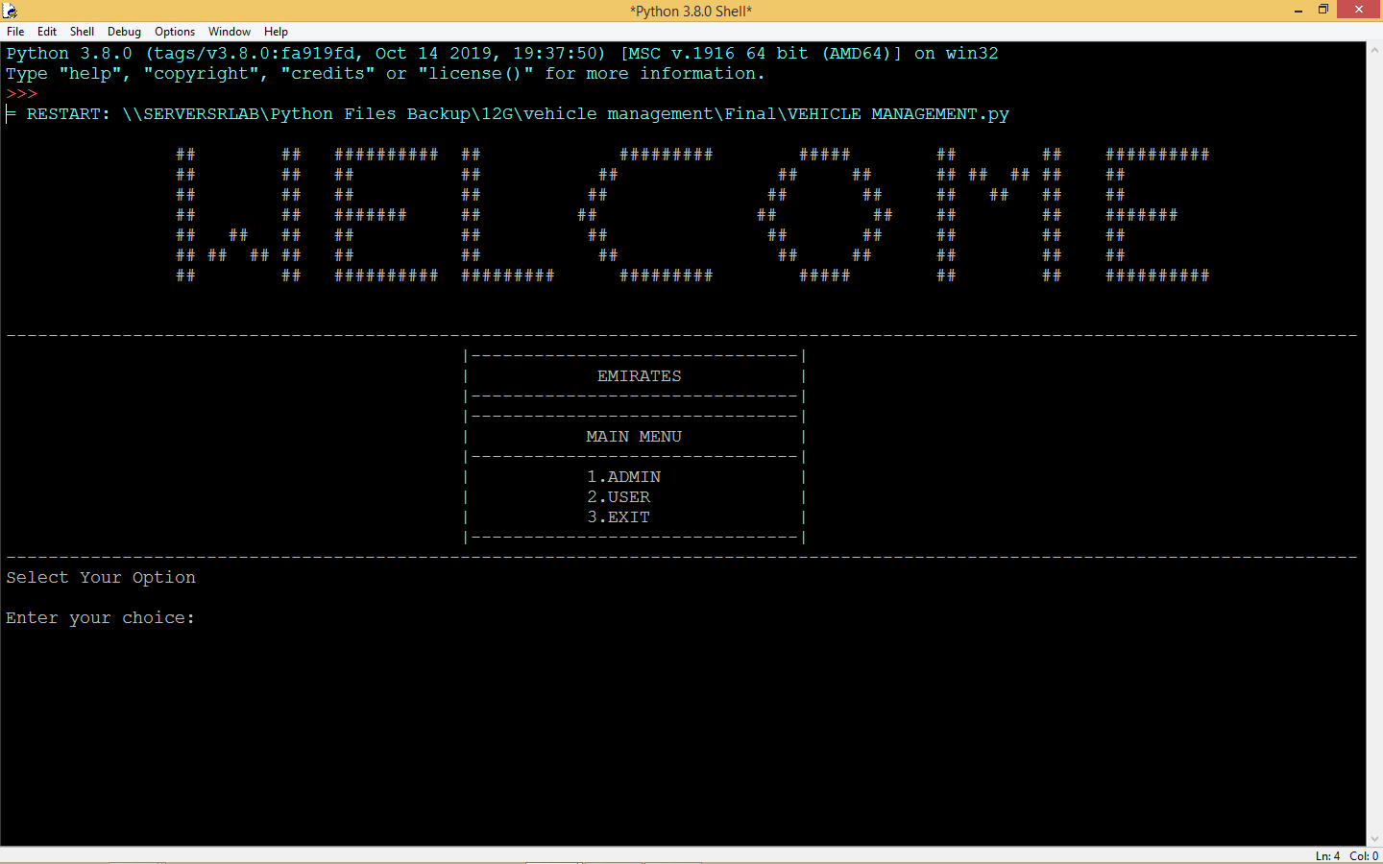

**USER  
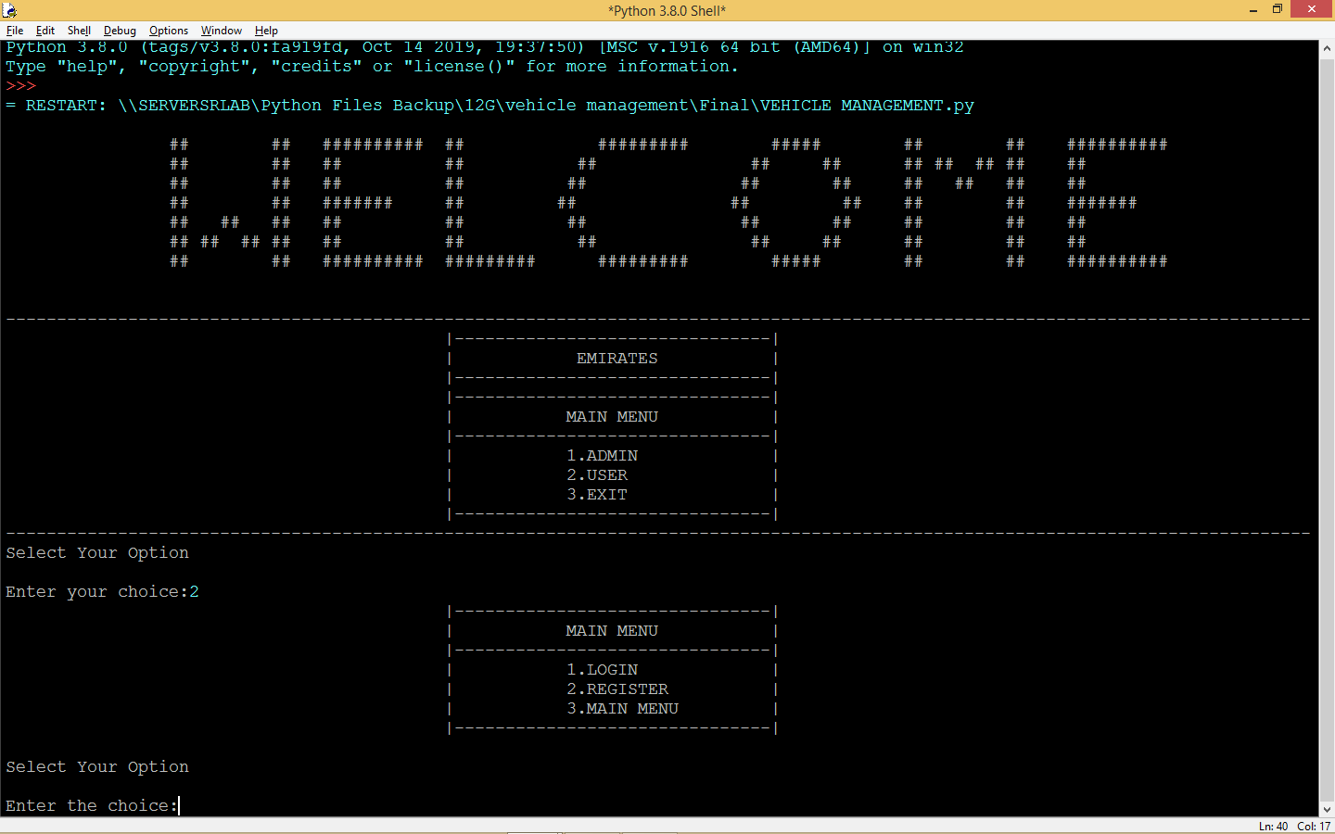**

**USER REGISTRATION:**

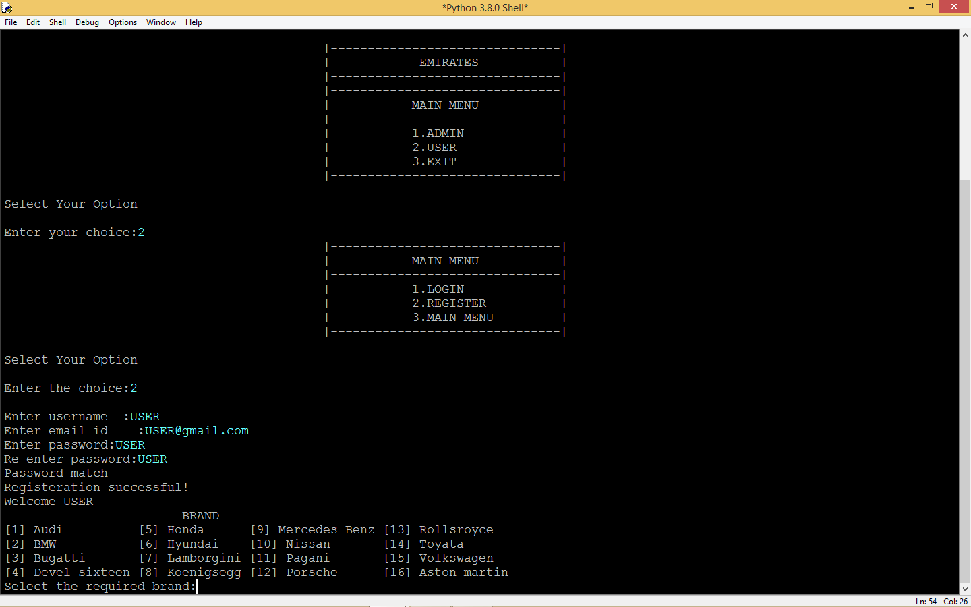

**CAR SELECTION:**

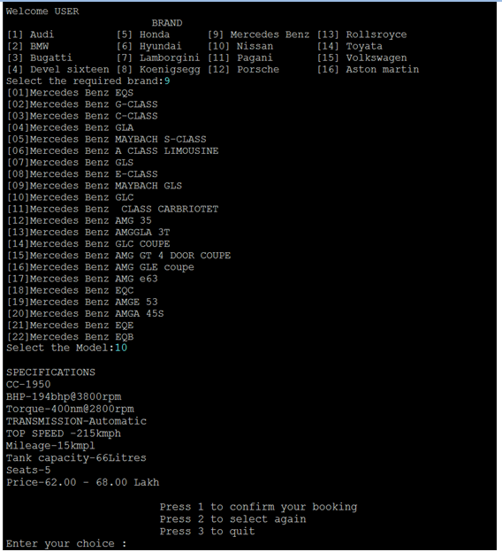

**RESELECTION:**

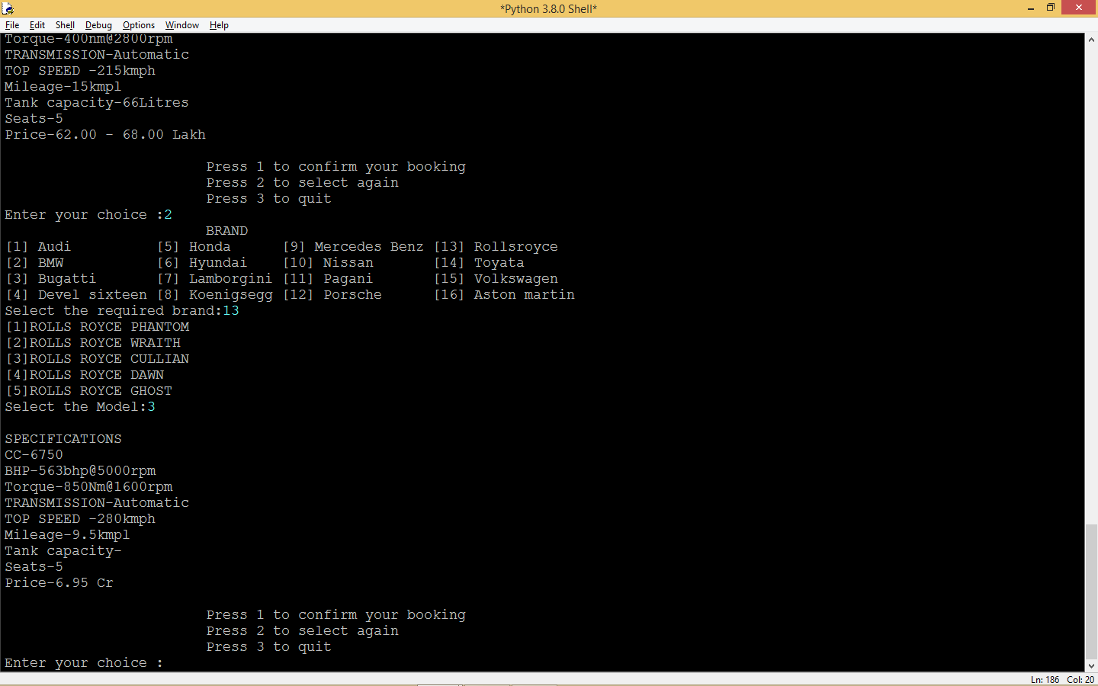

**CONFIRMATION:**

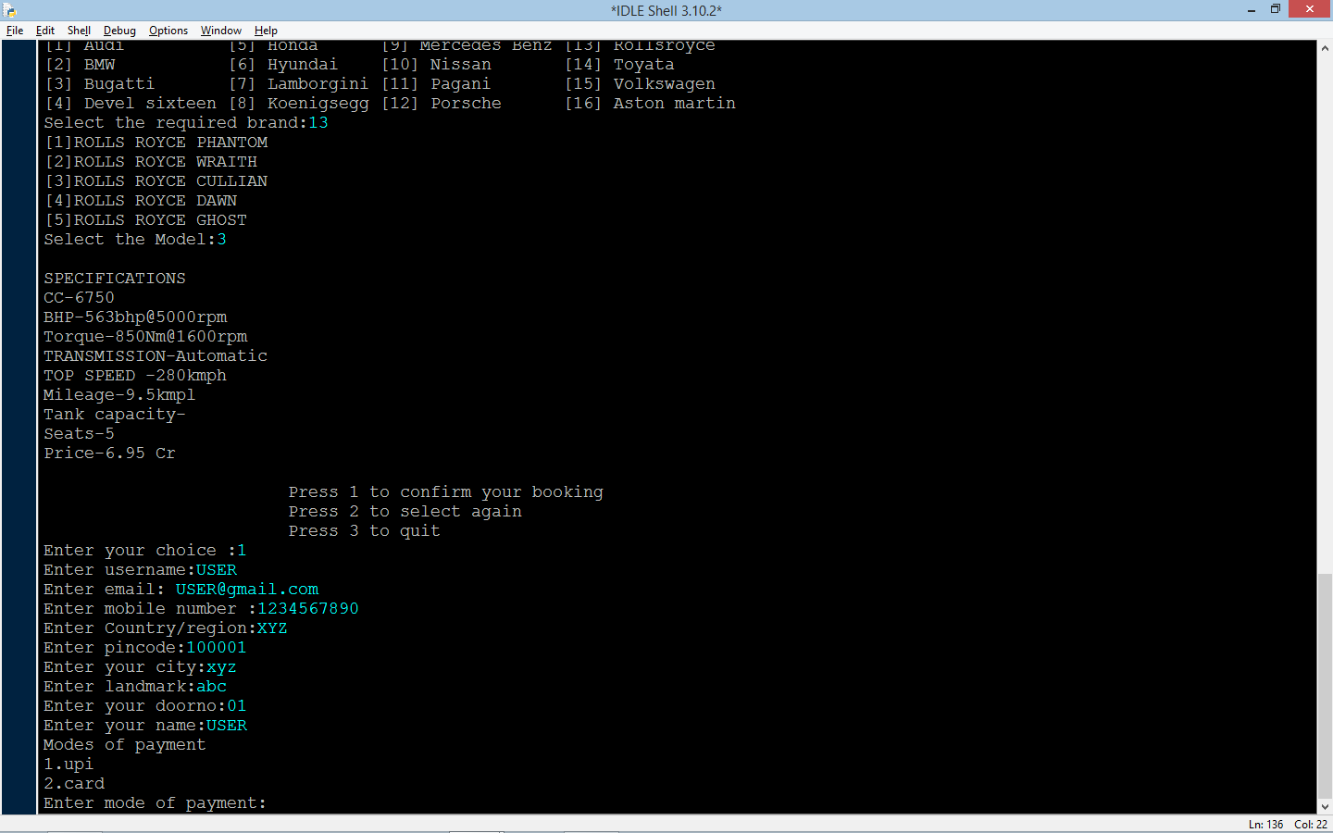

**PAYMENT:**

* 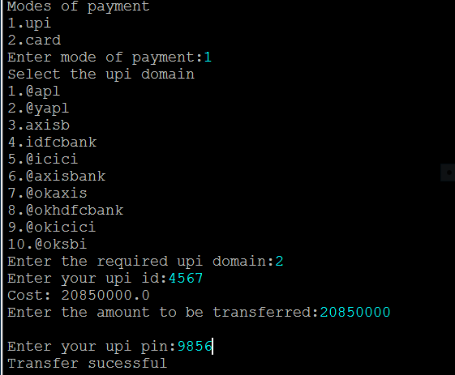**UPI**
* CARD:

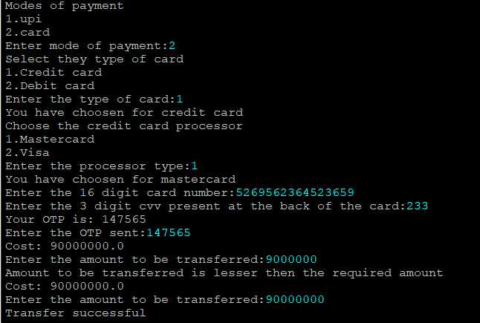

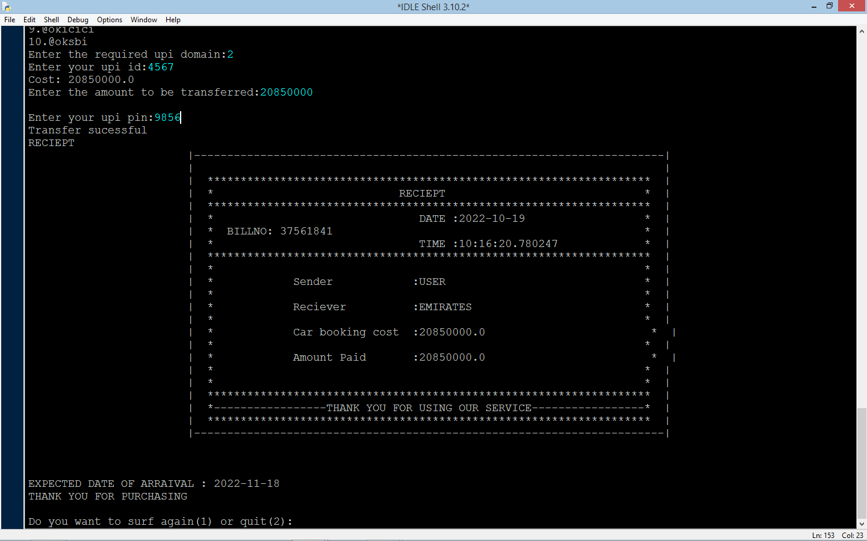RECIEPT:

LOGIN AFTER BOOKING:

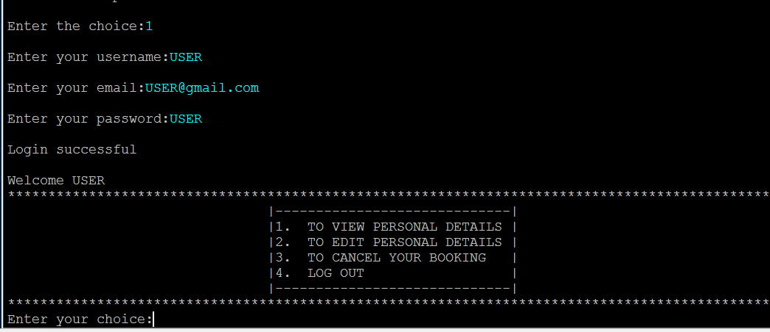

VIEWING PERSONAL DETAILS:  
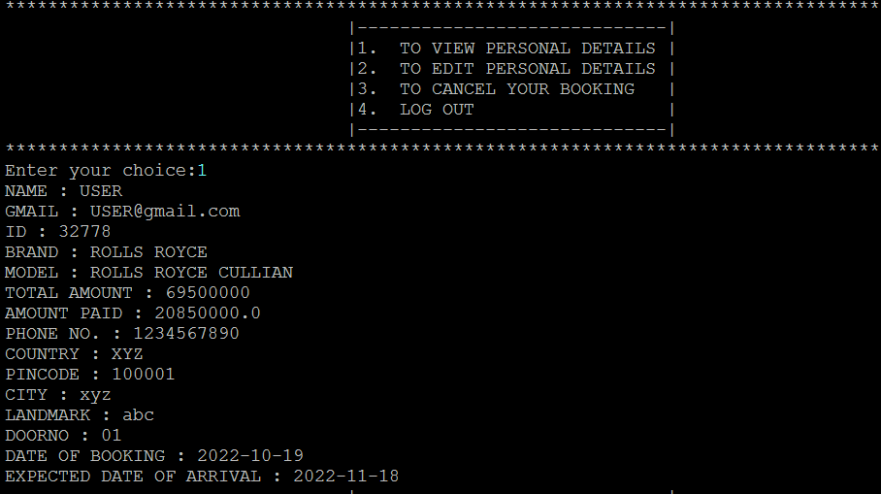

EDITING PERSONAL DETAILS

* EDITING USERNAME:

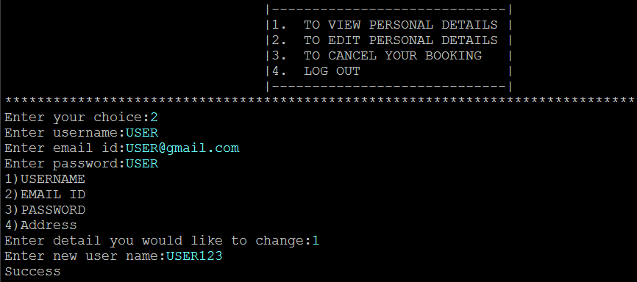

* EDITING GMAIL:

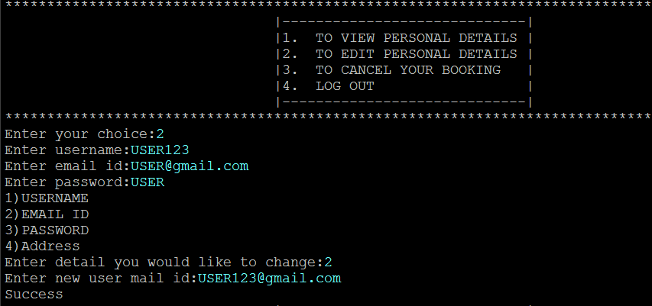

* CHANGING PASSWORD:

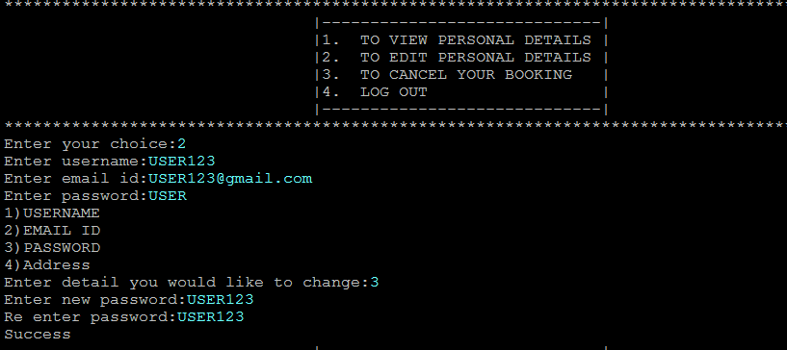

* EDITING ADDRESS:

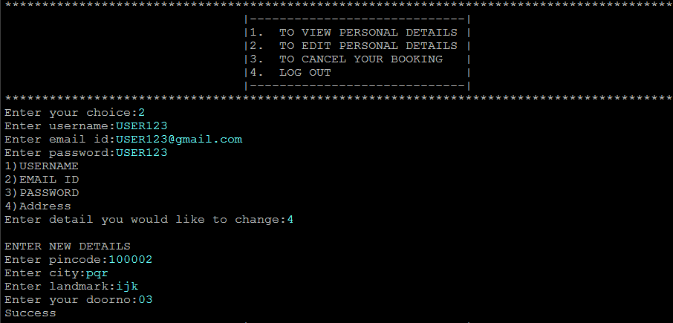

VIEWING DETAILS AFTER EDITING

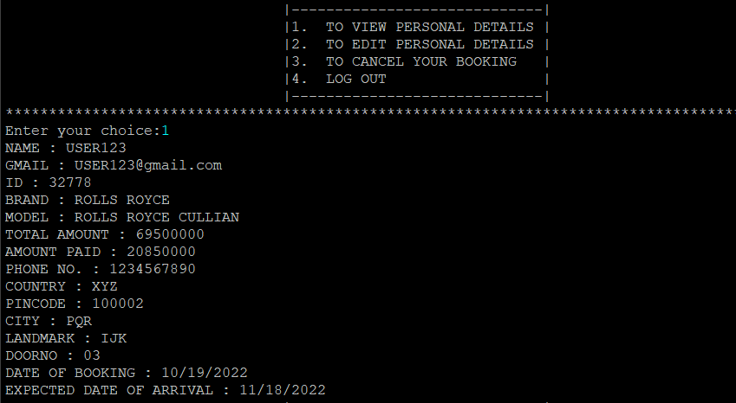

**ADMIN**:

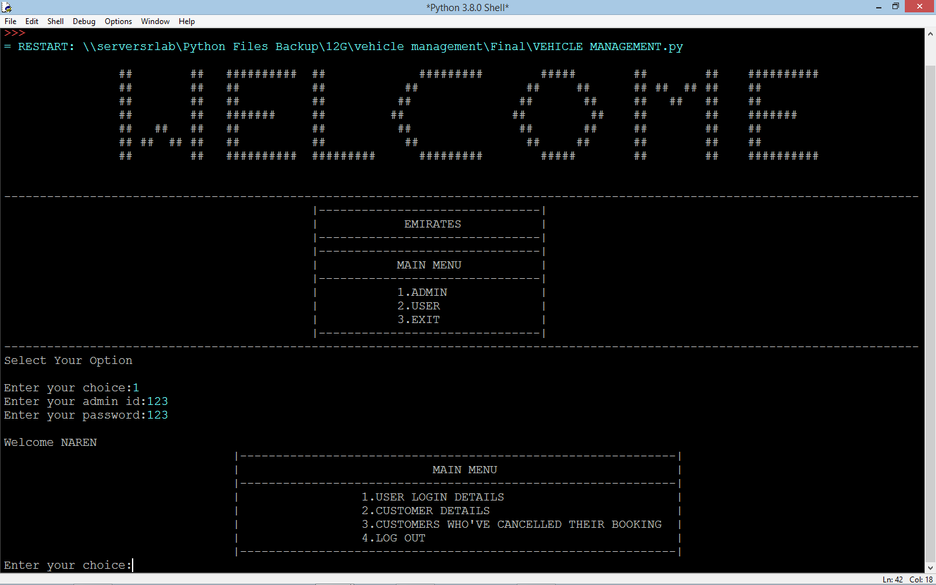

USER LOGIN DETAILS:

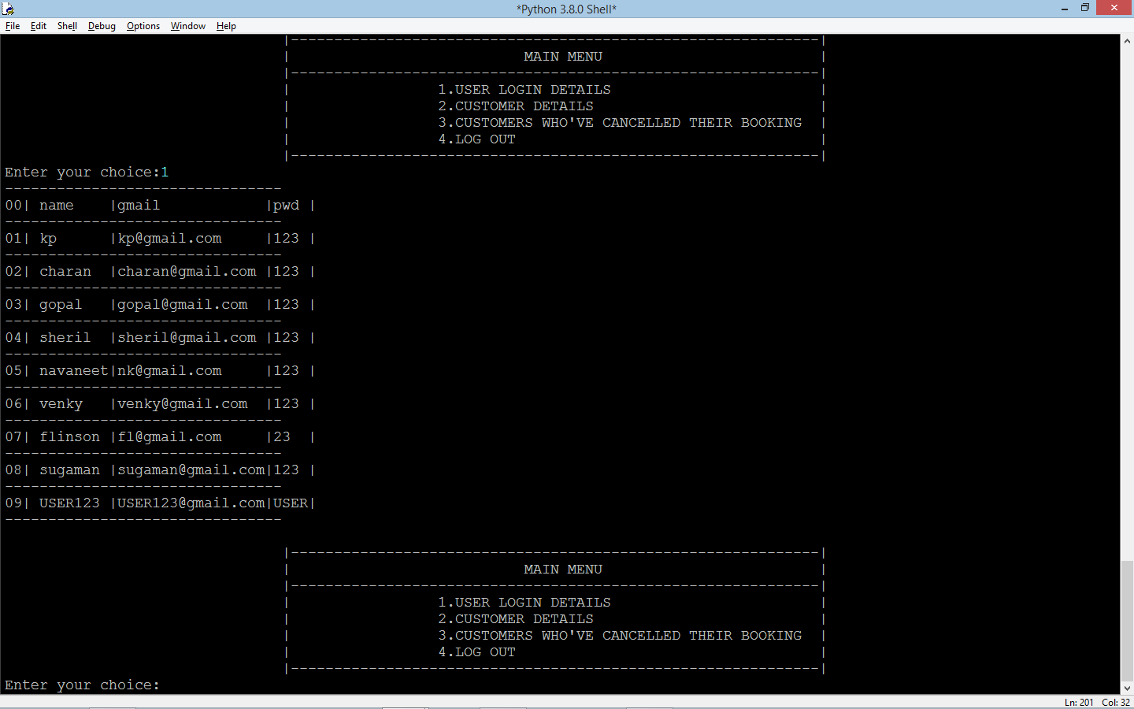

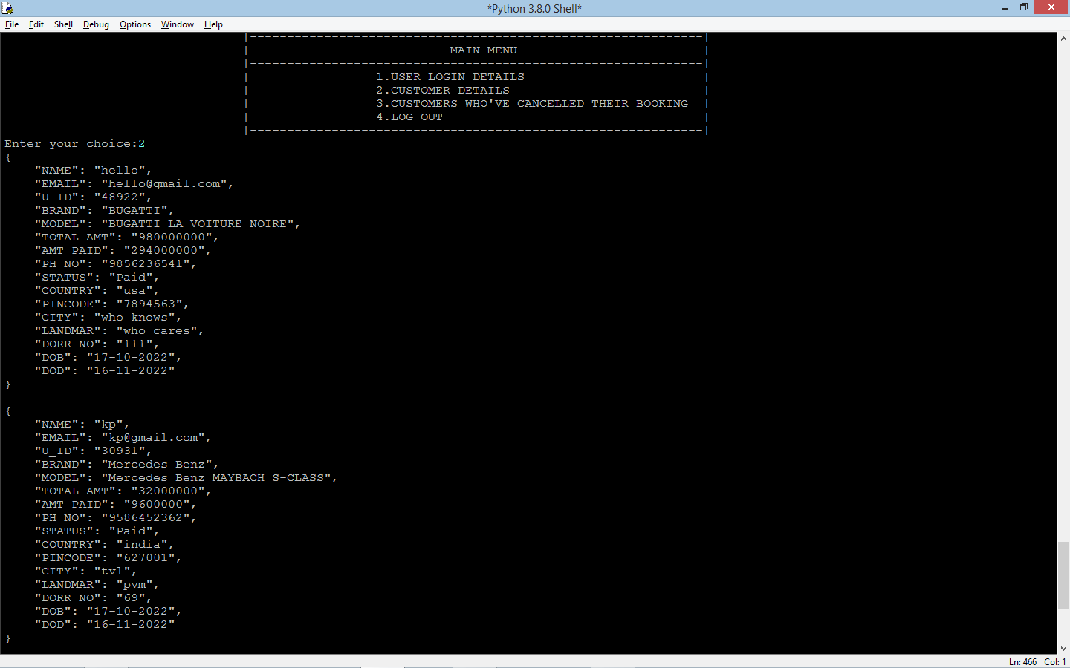 CUSTOMER DETAILS:

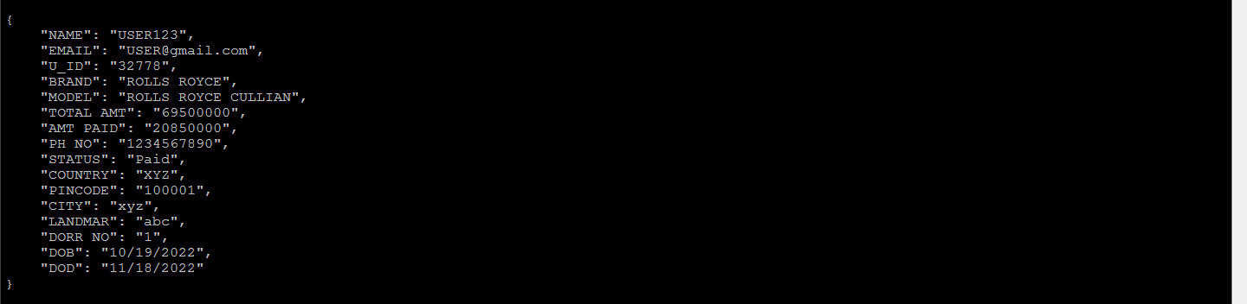

CANCELLED BOOKING:

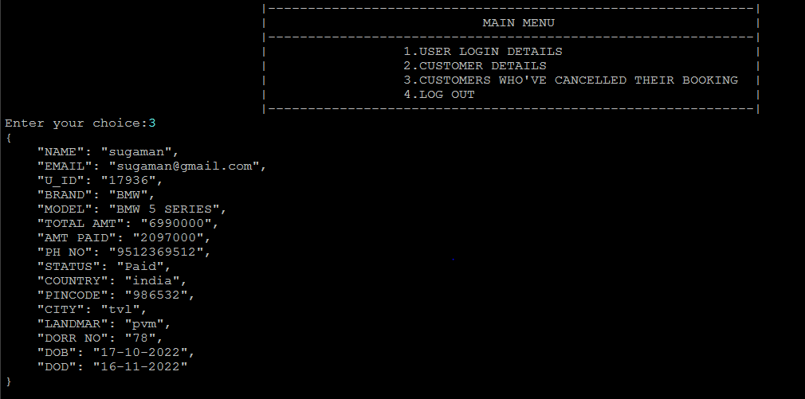

**ERRORS:**

Invalid choice:

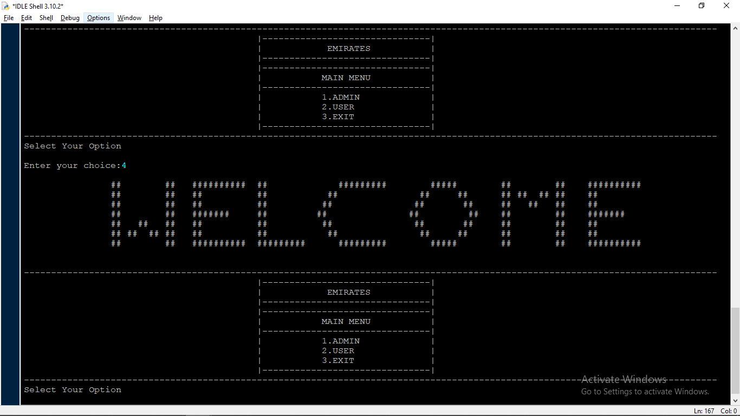

Admin – Suspicious login attempt:

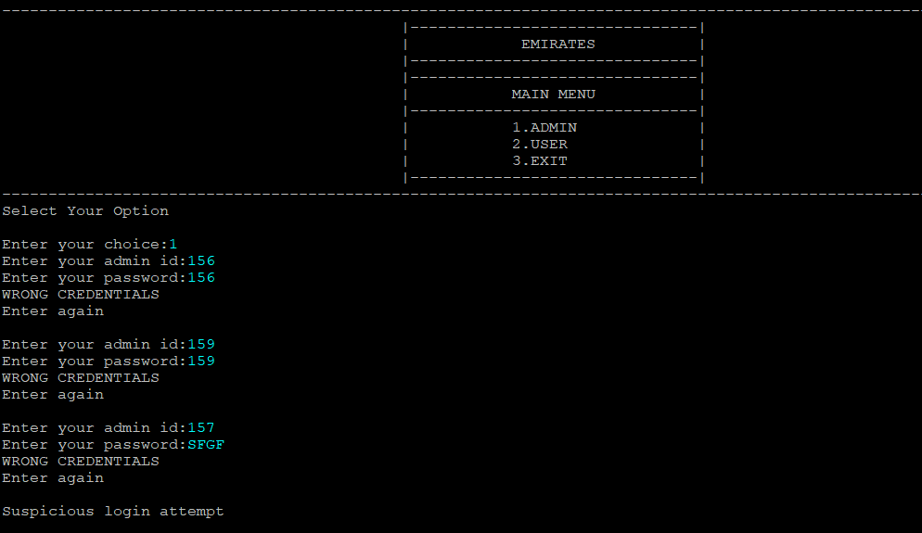

User – wrong credentials:

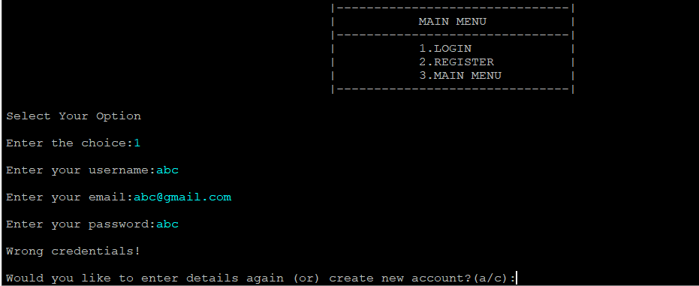

User- choosing inappropriate brand:

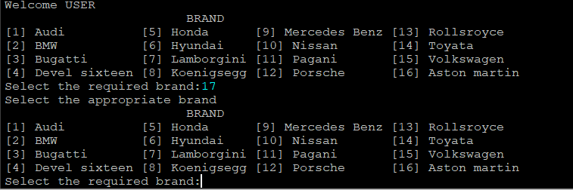

User- invalid phone number

